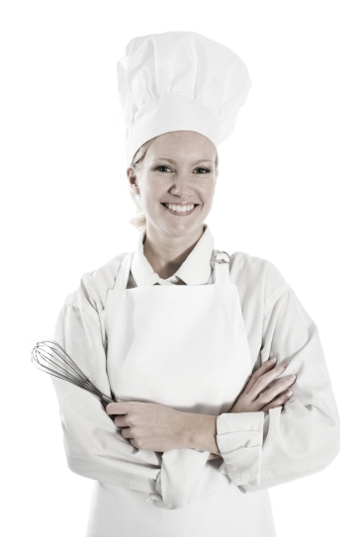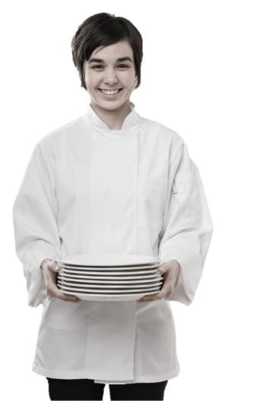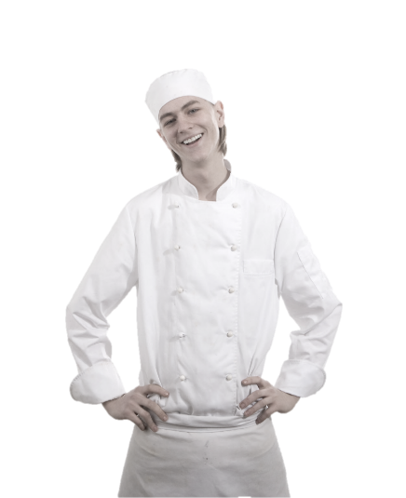

**Dishwasher**

**Training Manual**

**2019**

**Employment Policies and Procedures**

Standard Operating Procedures

Table of Contents

Introduction

Dishwasher Functions & Responsibilities

* General Job Guidelines And Responsibilities
* Dishwasher Job Functions

Security

Kitchen Sanitation & Cleanliness

* Major Causes of Food Borne Illness
* Kitchen Cleanliness

Performance Standards

* Eating or Drinking
* Opening, Running, Closing Duties

Conclusion

# Introduction

Congratulations on being selected to perform one of the most important, challenging and rewarding jobs at the Maple Leaf Diner!

As a Server, you will set the stage and have a direct impact on each guest's experience. You will determine whether each guest feels welcome, appreciated and well cared for.

We will provide you with the training you need to be successful. We take great pride in our quality food and friendly, responsive service. Our high standards can only be maintained through great people like you who share our values and desire to do the very best job possible for our guests every day.

As a server, it is essential that you maintain an energetic, friendly and caring attitude at all times. It is your responsibility to see that each guest is made to feel special and enjoys our fun atmosphere and great food and beverages.

The guidelines listed on the following pages have been established to help you in your effort to provide these qualities to our guests. Along with the hands-on training you will receive, this manual will provide answers to questions you may have regarding your tasks, responsibilities and operating procedures.

Once again, welcome to the Eh-Team!

# Dishwasher Functions & Responsibilities

Your role as a Dishwasher is extremely important to our restaurant. Your speed and efficiency are imperative to the smooth operation of customer service. You have a major role in and responsibility for the quick turnover of tables. Your efficiency and cleanliness will help assure 100% guest satisfaction. Hospitality is our keynote, and “You Can Make a Difference” is our key phrase: both are essential to keep our customer coming back.

## General Job Guidelines And Responsibilities

Ensuring the **cleanliness** of every dish, pot, pan, piece of silverware, and glass that goes to the kitchen and our guests.

Ensuring the dish machine is **operating at correct temperatures** in all cycles.

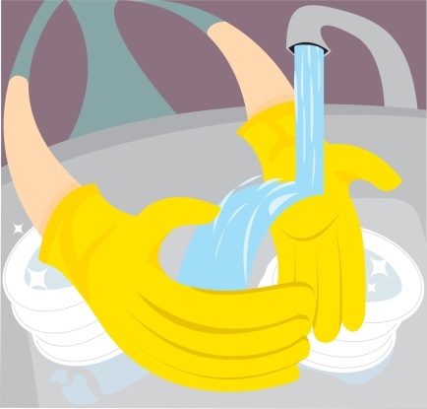Ensuring that the **proper detergents** (and levels of detergents) are being used in the dish machine and pot washing sinks.

Ensuring that the **proper sanitizers** are being used when cleaning walls, countertops, and floors.

Maintaining an **inventory** of all dishes, pots, pans, silverware, glassware, and kitchen utensils, which enables us to control loss and waste.

Maintaining a **waste management** program in the dish area: controlling unnecessary disposal of wrapped and/or unused crackers, Sweet n’Low, tea bags, creamers, jellies, knives, forks, spoons, ramekins, napkins, dishes, bowls, and glasses.

Maintaining **safe**, **clean**, and **organized** walk ways in the kitchen.

**Assisting** kitchen with prep work during off peak hours.

You are to ensure that the dish area, kitchen floor, employee restrooms, employee break area, and storage areas are **spotlessly cleaned at all times**.

You are responsible for the **back dock** and **dumpster** areas. You must maintain these areas so that they are free from debris at all times, to prevent the unsanitary habitation of rodents.

You are a total **team** **player** that provides services that link all departments together, while ensuring 100% guest satisfaction.

A good Dishwasher must be able to perform his or her job duties thoroughly, to support the whole staff; and, must be fast, to keep up with our volume of business.

Much of a Dishwasher’s job is involved with maintaining standards of cleanliness in the store. A good Dishwasher must be aware of our standards and must be able to work quickly and maintain them.

## Dishwasher Job Functions

1. **Stack dishes in dish racks.** Do not stack dishes on top of each other. To clean, water must have access to both sides of dishes.
2. 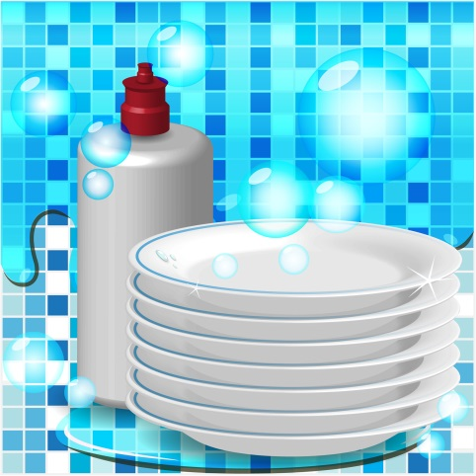**Glasses, cups and bowls** should be turned upside down so they will not fill up with hot water.
3. **Plates** and all **flatware** should be stood up edgewise.
4. **Dishes** should be allowed to air dry for 1-2 minutes before removing from racks. **Do not towel dry**. Towel drying will contaminate the dishes.
5. **Don’t** touch the surface of any glasses or plates that a guest’s mouth will touch.
6. Store cups, bowls, pots, pans, etc., **upside down**.
7. Handle silverware and other utensils **by the handles only**.
8. Always store kitchen utensils at least **6 inches off the floor** in clean, dry areas.
9. **Inspect** all items coming from the dish machine –

* Be certain there are **no stains or spots**.
* All items are **clean** and **free of food**.
* **No soap** on any items.
* **No chips** or **cracks**.
* Dishes come out **hot** from 140° rinse water.

# Security

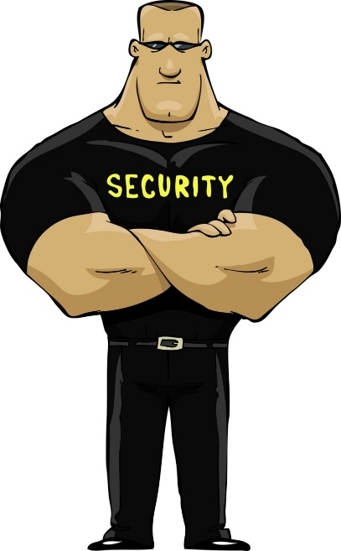As a Dishwasher, you have a very important role in the security of the Restaurant. **The back door must be kept closed and locked at all times**.

**During delivery hours**, a Manager will always be present at the back door. Whenever someone rings the back door, find a Manager; the Manager will open the door.

**When taking out trash**, find a Manager; the Manager will open the door and stand guard as trash is being removed.

You, as a Dishwasher, must abide by these policies at all times. The security of the Restaurant, the customers, and the staff (this includes you) is of the utmost importance.

# Kitchen Sanitation & Cleanliness

Throughout your training, you will receive information concerning proper cleanliness standards, proper use of chemical cleaning, and disinfectant products. It is always our #1 objective to operate our restaurant at the highest level of sanitation and cleanliness for the benefit of our guests and employees.

### Dispose Of Waste Properly

Take garbage out **frequently**.

Keep garbage areas **clean** and **sealed**.

Clean and sanitize garbage cans **regularly**.

Store **soiled** **linen** in a laundry bag or non-absorbing container.

### Keep Insects And Animals Out By

Keeping doors **closed**.

Taking garbage out **frequently** and keeping garbage areas **clean**.

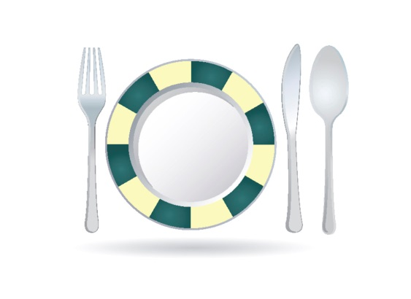**Report** any holes where an animal can enter.

**Do not** provide a free meal for any animals.

### Handle Ice And Tableware Properly

**Use** clean scoops or tongs to pick up ice, **do not** use hands or glass.

Store scoops or tongs in a **clean container**, not in the ice.

**Do not** store any food or beverage in the ice.

**Avoid** touching food contact surface with dishes, utensils, etc.

## Kitchen Cleanliness

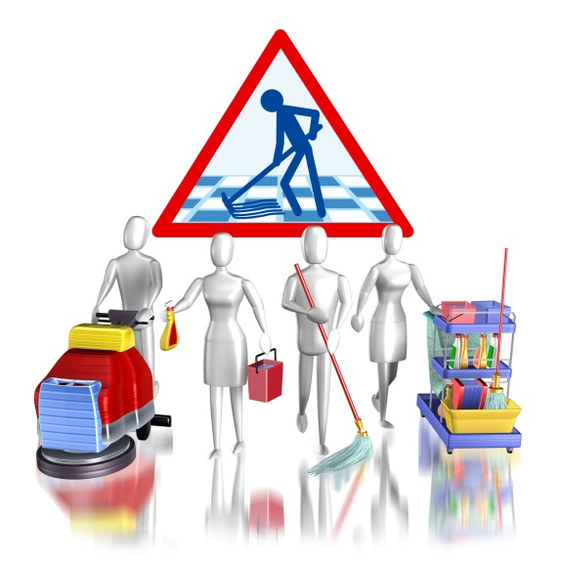**Sanitation solution** (spray) should be **used on all food contact surfaces** after they have been cleaned or when switching from one food product to another.

**Sanitation solution should be always be accessible in the kitchen.** Frequently rinse all cloths used to wipe counters in this solution.

**Store** all cleaning products, insecticides, poisons and chemicals AWAY FROM FOOD.

**Wash mops like brushes** – in hot water and hang to dry. Rinse mop buckets **immediately** and store after use.

**All employees** should help maintain clean and organized walk-in, freezer, dry storage and other storage areas.

All pots and pans, food storage containers and trays should be **inverted** after cleaning.

**Maintain and clean kitchen equipment on a regular basis.**

**Clean** microwave oven door seals and cavities regularly.

### Sanitation Solution and Spray

**Our sanitation solution is safe to use on all equipment and surfaces that come into contact with food products**. It requires no rinsing or wipe down after use. It evaporates very quickly because it has a high bleach content.

Use our sanitation solution spray **frequently** and **generously**.

Plastic spray bottles should be used and **accessible anywhere in the kitchen**.

**After cleaning equipment** and counters, spray generous amounts of sanitation solution.

Clean towels should be available for use with sanitation solution.

# Performance Standards

1. If you **fail to show up for a shift**, you will meet with the General Manager prior to your next scheduled shift.
2. **Notify** a Manager of anything out of the ordinary, or any possible problem.
3. A **smile and friendly attitude** are part of everyone's uniform and will increase your income.
4. **All employees are required** to have a telephone number where they can be reached.
5. If you notice anything in the Restaurant that is broken or damaged, **notify a Manager**.
6. **Do not** leave your station on break without checking with the kitchen Manager.
7. **Do not** eat, drink, or smoke while on the floor.
8. A Manager **must approve** all schedule changes.
9. Keep break area clean. **Do not** leave glasses, ashtrays, napkins, etc., lying out.
10. You must clock in and out as scheduled. **BE ON TIME**!
11. Print a copy of your schedule each week. Do not call up to the Restaurant to find out your schedule. **You are responsible for knowing your schedule**.
12. You **may not** receive personal phone calls at the Restaurant, **except in a real emergency**. Please inform your friends and family.
13. **Schedule requests** are due by the Saturday prior to the Thursday posting. Leave them in the designated area.
14. If you have a suggestion on how to make the Restaurant run more efficiently, **please give them to a Manager**.
15. You will maintain a **high level of communication** between bussers, kitchen line, kitchen prep, and dish staff. This is necessary to the flow of the restaurant.
16. **You will clean and sweep the kitchen and storage area, maintaining a safe and sanitary area for customers.**
17. **You will uphold sanitation and safety standards.**

## Eating or Drinking

There is to be no eating or drinking in the front of the house at any time. Food is only to be eaten during management approved breaks in appropriately designed areas.

## Opening, Running, Closing Duties

Every shift at the restaurant has opening, running, and closing duties. These duties are posted in the server stations, behind the bar, in the door book, and in the kitchen.

These duties are extremely important in assuring smooth daily operations and ongoing quality service. They require teamwork, and through teamwork, we will maintain excellence in service.

**Opening and closing duties will not be considered complete until approved by the Manager on duty.**

**Running duties** refer to ongoing duties while the Restaurant is open for business. The responsibility of making sure these duties are being done during the shift, is that of you and your teammates.

Each position of the Restaurant is assigned its own duties. Some duties will require individual effort, while others will require team effort.

# Conclusion

There is a lot of information contained in this manual! Believe it or not, however, there is even more information that is not.

We have given you the basics, as we view them, and how we would like them to be conducted.

We want you to use the service tips in the manual, along with your common sense, and above all, YOUR individuality, to help create an atmosphere that will encourage good times for our customers, and yourself. If this happens, you will be ensuring the success of not only the restaurant, but also yourself.

GOOD LUCK!!!