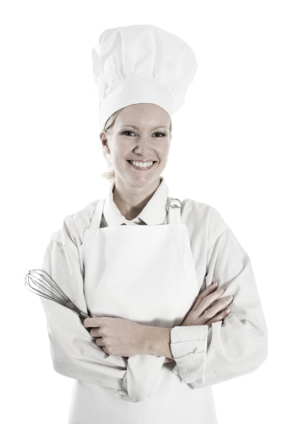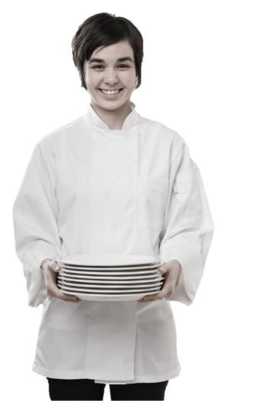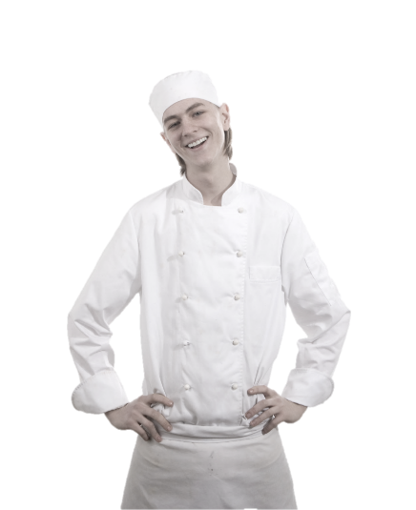

Standard Operating Procedures

**Busser**

**Training Manual**

**2019**

**Employment Policies and Procedures**

Table of Contents

Introduction

Busser Functions & Responsibilities

* General Job Guidelines And Responsibilities
* Responsibilities
* Qualities of a Good Busser
* Dish Room Responsibilities

Safety & Sanitation

* General Policy
* Beverage Service

Guest Care

* Importance of the Guest
* Bidding Farewell

Personal Appearance

* Uniform
* Dining Room Dress Code

Performance Standards

* Front of House Behavior
* Eating and Drinking
* After Shift Behavior
* Opening, Running, Closing Duties

Conclusion

**Introduction**

Congratulations on being selected to perform one of the most important, challenging and rewarding jobs at the Maple Leaf Diner!

As a Server, you will set the stage and have a direct impact on each guest's experience. You will determine whether each guest feels welcome, appreciated and well cared for.

We will provide you with the training you need to be successful. We take great pride in our quality food and friendly, responsive service. Our high standards can only be maintained through great people like you who share our values and desire to do the very best job possible for our guests every day.

As a server, it is essential that you maintain an energetic, friendly and caring attitude at all times. It is your responsibility to see that each guest is made to feel special and enjoys our fun atmosphere and great food and beverages.

The guidelines listed on the following pages have been established to help you in your effort to provide these qualities to our guests. Along with the hands-on training you will receive, this manual will provide answers to questions you may have regarding your tasks, responsibilities and operating procedures.

Once again, welcome to the Eh-Team!

# Busser Functions & Responsibilities

Welcome! You are now part of a TEAM dedicated to providing the very finest in dining and courteous service to every guest who walks through the doors. Hospitality is our keynote and "You Can Make A Difference" is our key phrase: both are essential to our continued success.

**You are a total team player that provides services that link all employee departments together, while having customer contact, ensuring 100% guest satisfaction.**

## General Job Guidelines And Responsibilities

Ensuring the **cleanliness of the Restaurant**, inside and out.

Ensuring the **cleanliness of the restrooms**, on a consistent basis.

Assisting with the **cleanliness of customer service areas**: i.e., tables, chairs and booths, and the floor.

**Assisting the host** with seating rotations by rapidly cleaning tables, chairs, booths, floors; and, by notifying the host of available seating.

**Assisting sales staff** with specific needs for the table: i.e., clearing plates, bringing fresh silverware, refilling coffee, tea, water, and crumbing table.

**Assisting bartenders** with needs for the bar: i.e., glassware, bus tubs, juices, ice, etc.

**Assisting the kitchen** by bringing dirty plateware, silverware, and glassware to the kitchen, and restocking the service stations with clean plateware, silverware, and glassware.

**Stocking service stations** with food service items: i.e., coffee, cream, cut lemons, soup spoons, iced tea spoons, etc.

Your efficiency and speed contribute to customer turnover, which is a vital aspect of our high-volume Restaurant.

In your interactions with customers, you are expected to uphold our standards of excellent service and hospitality.

## Responsibilities

Keep server prep area clean.

Spot sweep server prep area floor.

Assist in checking restrooms (every 15 minutes).

Assist in maintaining general cleanliness of the entire Restaurant.

Keep all stations fully stocked with glasses, coffee mugs, silverware,

assorted spoons, lemons, etc.

Bring back all dishes, glassware, silverware, etc.

Spot sweep Restaurant and bar floor.

## Floor Plan

You will be required to identify the following areas of the Restaurant:

Station Numbers

Table Numbers

Front Bar

Restrooms

Location of Pay Phones

Schedule Bulletin Board

Time Clock Computer

## Qualities of a Good Busser

|  |  |
| --- | --- |
| **Efficiency and Speed** | A good busser must be able to perform his or her job duties thoroughly, in order to support the service staff and hosts; and, must be fast to keep up with our volume of business. |
| **Customer Consciousness** | The customer is the most important person in the restaurant. Even though direct customer involvement in not part of your job description, you should be alert to customer's needs. This may involve giving directions to the telephone or restrooms, finding a server or Manager to help a party, and many other small services. The most important thing is to care about our customers and recognize their needs. |
| **Attention to Cleanliness and Sanitation** | Much of a busser's job is involved with maintaining standards of cleanliness in the store. A good busser must be aware of our standards and must be able to work quickly and maintain them. |

## Dish Room Responsibilities

On some shifts Bussers can also be responsible for helping out in the dish room. Here are general procedures for washing dishes:

1. **Stack dishes in dish racks.** Do not stack dishes on top of each other. To clean, water must have access to both sides of dishes.
2. Glasses, cups and bowls should be turn **upside down** so they will not fill up with hot water.
3. Plates and all flatware should be **stood up** edgewise.
4. **Dishes should be allowed to air dry for 1-2 minutes** before removing from racks. Do not towel dry. Towel drying will contaminate the dishes.
5. **Don’t touch** the surface of any glasses or plates that a guest’s mouth will touch.
6. Store cups, bowls, pots, pans, etc., **upside down**.
7. 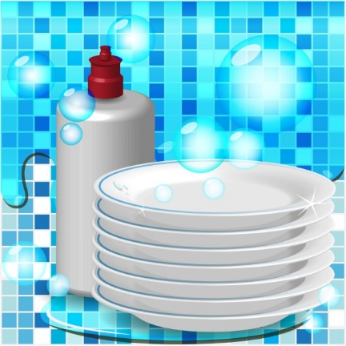Handle silverware and other utensils by the **handles only**.
8. **Always** store kitchen utensils at least 6 inches off the floor in clean, dry areas.
9. **Inspect** all items coming from the dish machine –

**Be certain** there are no stains or spots.

**All** items are clean and free of food.

**No** **soap** on any items.

**No chips** or **cracks**.

Dishes come out **hot** from 140° rinse water.

# Safety & Sanitation

**General Policy**

The responsibility of management and staff to protect the public from food borne illness is fundamental.

A **food borne illness** is simply a disease that is carried, or transmitted, to human beings by food.

Throughout your training, you will receive information concerning proper temperatures of food storage and serving, as well as, cleanliness standards, proper use of chemical cleaning, and disinfectant products. It is our objective to operate the restaurant at the highest level of cleanliness and sanitation for the benefit of our customers and employees. **Refer to our safety and sanitation policies in the Employee Handbook.**

**Beverage Service**

* **Always** use a designated ice scoop (Never use a glass to scoop ice).
* **Always** store ice scoops in a desingted container.
* **Always** use the deesinated tongs to retrieve lemon wedges.
* When refilling beverages, **never** touch the guests glass or straw to the pitcher.
* When refilling beverages at the soda station, ensure that the straw never touches the soda and nozzle.
* **Always** store ice bickets inverted on a hook. They should **never** be sotred directly on the foor.

# Guest Care

**C:\Users\Karens Laptop\AppData\Local\Microsoft\Windows\Temporary Internet Files\Content.IE5\Q73I4Y2H\MC900441830[1].wmfNever underestimate the importance of a guest!!!**

A guest is NEVER an interruption of our work - he is the purpose of it.

A guest is a person who brings us his wants -- it is our job to fill those wants.

A guest is deserving of the most courteous and attentive treatment we can give him.

A guest is the lifeblood our restaurant.

## Bidding Farewell

We have four distinct objectives with every departing guest:

1. To make sure their **experience** in our Restaurant was **pleasurable**.
2. **To thank them**, by name, for their patronage.
3. **To invite them back** for another visit soon.
4. To make sure their last impression is a **positive** one.

Host staff, bussers, servers, and managers all have the responsibility to bid our departing guests farewell. Here is the behavior associated with a farewell that is guaranteed to generate a repeat visit:

Help guests on with their jackets or coats.

Open the door for every departing guest.

Thank guests by name and invite them back for a specific occasion.

It takes only a fleeting moment to wrap and deliver it, but the memory of it can last a lifetime. It's the only thing people can wear that never goes out of style. And, one size fits everyone. It is called a “Smile.”

**Personal Appearance**

**Your overall image is our image.** You make a distinct impression on each of our guests. The image you create can enhance or detract from our overall concept and the way our Restaurant is perceived in the minds of the guest. You are entrusted with handling our guests' needs and must, therefore, reflect cleanliness and wholesomeness at all times. Always remember . . .

1. You are responsible for keeping your uniform neat and clean at all times. There is no excuse for reporting to work out of uniform.
2. A smile is part of your uniform.
3. Do not report to work with an un-pressed or dirty uniform, or un-kept hair.

**Uniform**

When you walk through the front door of the Restaurant, "YOU ARE ON.” You will be informed of the uniform requirements when you start with us. Your designated uniform also includes a CONTAGIOUS, ENTHUSIASTIC ATTITUDE. You are required to enter the building for your shift in FULL UNIFORM. You are also required, when you leave the building, to be in FULL UNIFORM.

**Dining Room Dress Code**

**Shoes** – Clean solid black shoes (no colored stripes or logos) designated by the manufacturer to be slip-resistant or skid resistant. Must be closed toe and closed heel (no clogs). Socks must be black.

**Pants & Belts** – Clean professional looking, wrinkle-free black slacks / pants (dry cleaning / creases not required). Pants must be long enough to cover shoe tops. Lycra / polyester stretch knit, corduroy and linen pants are not acceptable and may not be worn. No rolled cuffs and no large pockets. Black belt or no belt.

**Shirts** – All shirts must be clean and wrinkle free. Black Maple Leaf Diner T-shirt or solid black t-shirt that is not faded and at least medium-weight material. The material must be thick enough, so it is not transparent.

**Accessories** - No cologne or perfume No excessive make-up or jewelry. No earrings longer than 1 inch. No hats.

**Apron** – Maple Leaf aprons must be purchased for $15.

**Miscellaneous** – Please have a wine opener, lighter and at least 2 pens at all times.

# Promotions

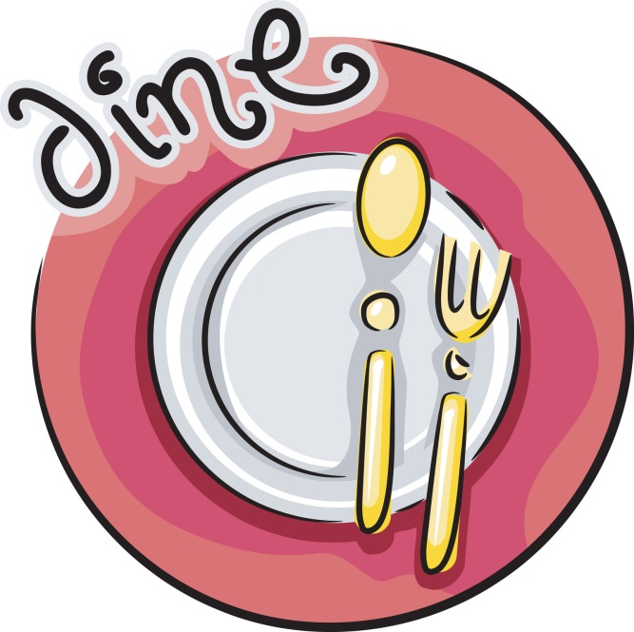Be aware of all in-house promotions that are currently in action, and those that are upcoming. Your Management team will notify you of all promotions at the daily pre-shift meetings. Advertising brings the product to the consumer; promotion brings the guest to the product. We have found that our sales volume increases when special promotions occur. We expect all staff to promote all activities with enthusiasm. Our biggest return should be from word-of-mouth through our staff. An example of a promotion may be the annual “Mardi Gras Party”. As a Busser you may recognize a lunch customer invite them to come in and participate. When that guest leaves after lunch that day, thank them by name, and say, "Come back for happy hour our Margaritas are unbelievable." You have just successfully completed the "Sell to Sell Again" creed of our Restaurant. You enrolled a customer into an activity that day, and encouraged them to participate in an upcoming promotional activity. You, through your knowledge of in-house promotions, have just increased our sales potential.

# Performance Standards

We will make sure that the sidewalk and entryways are **always free from debris**.

When **cleaning a restroom**, we will collect glassware, clean sinks, sweep floor, check toilet paper, and soap supplies.

We will clean restrooms and **sign off on restroom maintenance** sheets every **15 minutes**.

We will keep any and all ledges and resting places clear of glasses, ashtrays, napkins, etc., and the floor swept, which will maintain a pleasant environment for our customer's.

We will **bus tables quickly and efficiently**, and keep bus stations stocked, understanding this is essential in teamwork and in turning tables.

We will keep a **high level of communication** between the Bussers and Host staff, which is necessary to the flow of the Restaurant.

We will make sure that our **floors are always spotless**.

We will **greet and bid farewell to all** of our customers.

We will clean and sweep bar area, maintaining a safe and sanitary area for our customers.

AND . . .

**Advise a Manager** of any customer who appears to be **intoxicated**.

IF YOU ASK TO LEAVE...YOU CLOSE.

If you **fail to show up** for a shift, you will meet with the General Manager prior to your next scheduled shift.

**Notify a Manager** of anything out of the ordinary, or any possible problem.

A smile and friendly attitude are part of everyone's uniform and will increase your income.

All employees are **required** to have a telephone number where they can be reached.

If you notice anything in the Restaurant that is **broken or damaged**, notify a Manager.

**Do not leave your station** on break without checking with a Manager.

**Do not** eat, drink, or smoke while on the floor.

You **must** be in your station working in completed uniform at your scheduled time.

A Manager **must** approve all schedule changes.

If you wish to continue to have a break area, **keep it clean**. Do not leave glasses, ashtrays, napkins, etc., laying out.

You **must** clock in and out as scheduled. **BE ON TIME**!

Print a copy of your schedule each week. **Do not** call up to the Restaurant to find out your schedule. You are responsible for knowing your schedule.

You **may not** receive personal phone calls at the Restaurant, except in a real emergency. Please inform your friends and family.

Schedule requests are due by the Saturday prior to the Thursday posting. Leave them in the designated area.

You **may not** come into the back of the house after you have been drinking. You **may not** take drinks into the break room.

If you want to return to the Restaurant after work and have a cocktail, maintain a very high standard of behavior and leave at last call.

If you have a suggestion on how to make the Restaurant run more efficiently, **please give them to a Manager**.

Remember to **enjoy yourselves and have fun** while you are here. Let the Managers handle all problems, big or small.

When your guests leave, you will **thank them for coming and invite them back.**

You will **clean stations** during your shift - **EVERYTHING** from floor to ceiling.

**No more than** two cigarette butts per ashtray. Cap them properly.

**Teamwork** is ESSENTIAL.

**Do not** grab glasses from people's hands at last call. **Find a Manager** and let them assist.

## Front of House Behavior

There is to be no yelling or arguing in the front of the house. If you have a problem with a customer, DO NOT ARGUE, keep calm, and get a manager. The same applies to employee relations. No yelling or arguing, - get a manager.

## Eating and Drinking

There is to be no eating or drinking in the front of the house at any time. Food is only to be eaten during management approved breaks in appropriately designed areas.

## After Shift Behavior

Employees may not sit with customers at a table or at the bar while in uniform. If you are visiting the restaurant off duty, you are still a representative of MLD. For this and other reasons, we will appreciate you maintaining a very high standard of behavior.

## Opening, Running, Closing Duties

Every shift at the restaurant has opening, running, and closing duties. These duties are posted in the server stations and behind the bar. These duties are extremely important in assuring smooth daily operations and ongoing quality service. These duties require teamwork, and through teamwork, we will maintain excellence in service.

**Opening and closing duties will not be considered complete until approved by the Manager on duty.** Running duties refer to ongoing duties while the Restaurant is open for business. The responsibility of making sure these duties are being done during the shift, is that of you and your teammates. Each position of the Restaurant is assigned its own duties. Some duties will require individual effort, while others will require team effort.

**Conclusion**

There is a lot of information contained in this manual! Believe it or not, however, there is even more information that is not.

We have given you the basics, as we view them, and how we would like them to be conducted.

We want you to use the service tips in the manual, along with your common sense, and above all, YOUR individuality, to help create an atmosphere that will encourage good times for our customers, and yourself. If this happens, you will be ensuring the success of not only the restaurant, but also yourself.

GOOD LUCK!!!