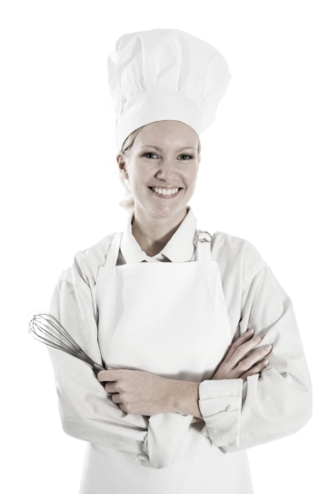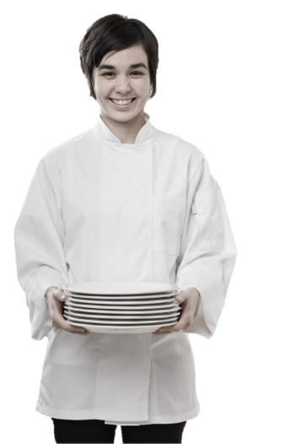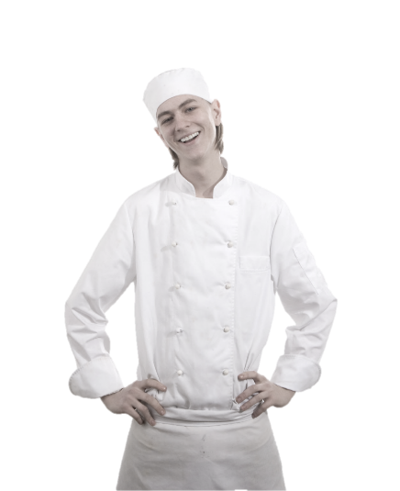

Standard Operating Procedures

**Host / Hostess**

**Training Manual**

**2019**

**Employment Policies and Procedures**

Table of Contents

Introduction

Host/Hostess Functions & Responsibilities

* General Host Information
* The Greeting
* Waiting Lists
* Telephone Procedures

Personal Appearance

* Uniform

The Guest

* Service
* Reservations
* Waiting List Calls
* Customer Complaints
* Diplomacy & Tact
* Bidding Farewell

Alcohol Awareness

* To Serve or Not to Serve
* Intoxication Behavioral Cues

Menu Knowledge

* Menu and Drink Prices
* Specialties
* Specials & Features Of The Day

Methods of Payment

* Credit Cards
* Checks

Performance Standards

* Points of Difference
* Front of the House Behavior
* Eating or Drinking
* After Shift Behavior
* Opening, Running, Closing Duties

Additional Host/Hostess Information

* Paging System
* Promotions
* Lost And Found
* Tipping

Conclusion

# Introduction

Congratulations on your employment as a host/hostess at the Maple Leaf Diner!

As a host/hostess you’ll be an important part of each guest’s experience in our restaurant. We will provide you with the training you need to be successful.

We take great pride in our quality food and friendly, responsive service. Our high standards can only be maintained through great people like you who share our values and desire to do the very best job possible for our guests every day.

The guidelines listed on the following pages have been established to help you in your effort to provide these qualities to our guests. Along with the hands-on training you will receive, this manual will provide answers to questions you may have regarding the operating procedures for MLD.

# Host/Hostess Functions & Responsibilities

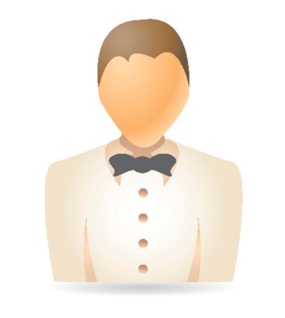Welcome! You are now part of a TEAM dedicated to providing the very finest in dining and courteous service to every customer who walks through the doors.

Hospitality is our keynote and "You Can Make A Difference" is our key phrase, as it is essential to our continued success.

As the Host/Hostess of the "party," you must make the guest feel welcome.

* You should provide a cheery greeting, a compliment, and recognize regular customers by name.
* You should make each and every guest feel "special." It is up to you to make them feel at ease and welcome. A guest may have had a hard day at the office, and now wants to relax; a guest may be celebrating a special occasion; a guest may be lonely and want to meet people. Whatever the reason, you are the host, a salesperson with the answers to any and all questions and needs.
* You are the life of your party: You must keep your energy level and enthusiasm up, entertain your guests, and make your service special. The excitement of the aroma, the decor, the music, and the lighting are stimulated by your dynamic personality and service.
* You are the first person a customer sees; so, greet the customer with a smile. The customer's first impression of our Restaurant is you. All incoming guests must receive a friendly, sincere greeting.

As the Host/Hostess, you are also the last person the guest will come in contact with. When the customer leaves, the door should be opened, the customer thanked, and invited to return. Provide the guest with a good last impression of our Restaurant.

Our Hosts/Hostesses are successful because of TEAMWORK. In order for a team to function effectively, it must be guided by certain basic principles. The information, instructions, and philosophies in this manual are the basic principles to which you will be expected to adhere to.

Remember, you set the mood for the guest. The smiles you put on people's faces through your dealings with them -- whether answering the phone, greeting, saying goodnight, or answering questions -- can "MAKE A DIFFERENCE."

## General Host Information

Whenever possible, open the front door for guests as they enter and leave.

There should always be someone at the front door. If you must leave for a minute, have someone cover for you.

Consistently check the lady’s and men’s rooms (approximately every 15 minutes), looking for trash, clean mirrors, and toilet paper stock.

Keep Host stand clean.

No employees are to receive phone calls. If caller says it is an emergency, find a Manager.

When you are in the foyer or bar looking for people, do not carry your description or wait list. All the customers en route will stop you and ask you where they are on the list. Read the description, then go find the customer.

Your appearance and attitude is important. Customers watch the operation you perform, so do not look disorganized or mad. If you are having a problem, ask the Manager to help you.

Always address the customer first. If you are completing a seating “transaction,” let the customer know you will be right with him/her.

If you are going over your estimated times, immediately inform the Managers so that the wait staff can be alerted.

When talking on the phone, always smile, it will make you feel good!

In the evening, bid your guests, good night.

## The Greeting

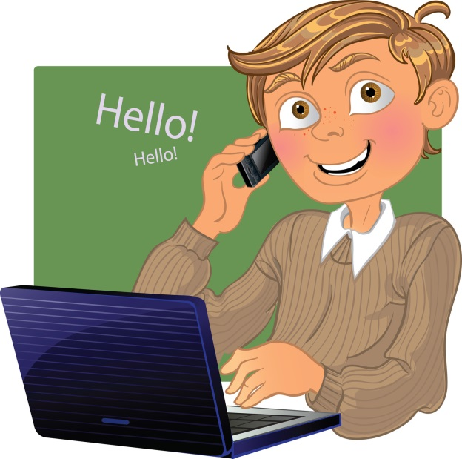**Your greeting is the guest's first impression of the Restaurant.** Remember, neither you, nor the Restaurant, get a second chance to make a good first impression.

Greet guests, whenever possible, within 30 seconds upon their entry to the Restaurant: i.e., "I'll be right with you," and use their names whenever possible.

Do not use the Host stand as a shield to stand behind.

Stand up front, do not make the guest approach you. You must make the first move in welcoming your new guests.

Make every guest feel wanted and appreciated the minute they set foot into our front door.

Your greeting should be changed to what feels comfortable to you.

Do not be repetitious by using the same greeting every time.

Be careful not to let the friends you make take up too much of your time.

It is of great importance, and a business value, that each guest receives a special greeting.

## Waiting Lists

Waits are difficult to determine because every day in the restaurant business is different.

Sometimes tables sit forever. There may be a lot of special gatherings: birthdays, anniversaries, or people may sit and discuss business. Other days, the tables will turn very fast.

**So, how do you determine what the wait time is?** The answer is not easy; therefore, always ask a Manager. Remember, the wait for tables of two and four are different than for large parties (five or more). If there is a waiting list, "sell" the wait rather than "challenge" a guest.

|  |  |
| --- | --- |
| WRONG | TRANSLATION |
| "Four for dinner? There is a twenty-minute wait!” | "Your move." |

|  |  |
| --- | --- |
| right | TRANSLATION |
| “Welcome to the Maple Leaf Diner. How are you this evening? How many in your party? May I please have your name. There is a short twenty-minute wait, but if you would like to have a seat, I'll come get you the minute your table is ready, Mr. Reynolds.” | "I know you hate to wait, but I'll do everything I can to make that wait as short as possible. I am happy you are here!" |

When you are ready to seat a customer, use the guest's name: i.e., "Mr. Jones, your table is ready!" or "Enjoy your lunch, Ms. Smith."

When seating a guest, inform them of our daily specials, and make suggestions: i.e., “Our Fresh Fish of the Day is a light, flaky amberjack fillet “. Don't forget to save room for dessert, the Key Lime Pie is wonderful, and satisfies any sweet tooth."

### Starting A Waiting List

Customer Name

Number in Party

Time Checked In

Time Quoted (estimated wait time)

Description (see below)

### Writing A Good Description

Women are usually easier to describe than men, so go for them.

Don't describe something they can take off: i.e., sweater, coat, etc.

Use abbreviations to speed up the process: L=Lady, M=Man, PtSt=Pant Suit.

A good description need not be lengthy to be accurate.

Estimated waits are increased by five (5) minute intervals. Waits should be updated continuously. Take into consideration the number of names on the wait list and the times seated on the floor plan.

### Seating/Seating Rotation

At the beginning of each shift, you will receive a floor plan with designated stations for the servers, as well as our smoking and non-smoking areas.

* Remember, seat two-tops with parties of two, before using four-tops for them.
* Seat four-tops at tables or booths, and parties of five or more at the large round tables, before putting tables together.
* Try to rotate from one station to the next whenever possible: i.e., station one, then two, three, etc.
* Try not to double seat a station unless the customer requests a particular table.

Once you leave the Host stand to seat a party, be certain to post the time seated on that table on your floor plan. As business slows down, stations may close, and the floor plan will change. A Manager -- and Manager only -- can close stations and change the floor plan.

## Telephone Procedures

Each time we answer the phone, we are selling the Restaurant to a potential customer. Answering the telephone is the responsibility of the host/hostess during operating hours; however, be aware when the phone is ringing and make sure it is answered after a maximum of two rings. The call should then be transferred to the managers, if necessary.

All waiting-list inquiries will be transferred to the host stand.

Answer the phone with a bright, cheerful, upbeat greeting, which creates interest and excitement. Use your imagination, but always be courteous and helpful. The phone should always be answered by the second ring.

### Example Of How To Answer The Telephone:

"Good afternoon/evening, thank you for calling the Maple Leaf Diner; this is ___________, may I help you?"

You will have a general information fact sheet with hours of operation, menu price scale, directions to MLD from different areas, specials, etc.

We will not allow employees to make or receive telephone calls, unless there is an emergency. If there is an emergency, get a Manager right away. Off-duty employees are not allowed to use the house phones at the hostess stand.

# Personal Appearance

**Your overall image is our image.** You make a distinct impression on each of our guests. The image you create can enhance or detract from our overall concept and the way our Restaurant is perceived in the minds of the guest. You are entrusted with handling our guests' needs and must, therefore, reflect cleanliness and wholesomeness at all times. Always remember . . .

* You are responsible for keeping your uniform neat and clean at all times. There is no excuse for reporting to work out of uniform.
* A smile is part of your uniform.
* Do not report to work with an un-pressed or dirty uniform, or un-kept hair.

**Uniform**

When you walk through the front door of the Restaurant, "YOU ARE ON.” You will be informed of the uniform requirements when you start with us. Your designated uniform also includes a CONTAGIOUS, ENTHUSIASTIC ATTITUDE. You are required to enter the building for your shift in FULL UNIFORM. You are also required, when you leave the building, to be in FULL UNIFORM.

**Dining Room Dress Code**

**Shoes** – Clean solid black shoes (no colored stripes or logos) designated by the manufacturer to be slip-resistant or skid resistant. Must be closed toe and closed heel (no clogs). Socks must be black.

**Pants & Belts** – Clean professional looking, wrinkle-free black slacks / pants (dry cleaning / creases not required). Pants must be long enough to cover shoe tops. Lycra / polyester stretch knit, corduroy and linen pants are not acceptable and may not be worn. No rolled cuffs and no large pockets. Black belt or no belt.

**Shirts** – All shirts must be clean and wrinkle free. Black Maple Leaf Diner T-shirt or solid black t-shirt that is not faded and at least medium-weight material. The material must be thick enough, so it is not transparent.

**Accessories** - No cologne or perfume No excessive make-up or jewelry. No earrings longer than 1 inch. No hats.

**Apron** – Maple Leaf aprons must be purchased for $15.

**Miscellaneous** – Please have a wine opener, lighter and at least 2 pens at all times.

# The Guest

**C:\Users\Karens Laptop\AppData\Local\Microsoft\Windows\Temporary Internet Files\Content.IE5\Q73I4Y2H\MC900441830[1].wmfNever underestimate the importance of a guest!!!**

A guest is not dependent upon us -- we are dependent upon him (or her).

A guest is NEVER an interruption of our work - he is the purpose of it.

A guest does us a favor when he comes here -- we are not doing him a favor by serving him.

A guest is part of our business -- not an outsider.

A guest is not a cold statistic -- human being with feelings and emotions, like our own.

A guest is a person who brings us his wants -- it is our job to fill those wants.

A guest is deserving of the most courteous and attentive treatment we can give him.

A guest is the lifeblood of our restaurant.

## You Must Be Able To Serve Many Different Types Of Guests

To make appropriate selling suggestions, and give good service, it is helpful to recognize and know how to handle all types of guests. For example

|  |  |
| --- | --- |
| The Timid Guest: | Genuine interest and patient understanding will put this type of guest at ease. Even a comment on the weather can make him feel at home. |
| The Aggressive Guest: | This type must be handled in a courteous and businesslike manner. Kindness and politeness can often change him into a steady and appreciative customer. |
| The Fussy Guest: | This is one of the hardest guests to please. Try to stay one step ahead of him by learning the things that irritate him. Be sure to have everything just right, before serving the fussy guest. Remember all of the little things the fussy guest especially likes, even when they may seem peculiar to the average person. |
| *The Over-Familiar Guest:* | *Be courteous, dignified, and avoid long conversations. Stay away from the table, except when actual service is needed. Never try to give a wise crack answer to a smart remark. You will only cheapen yourself and lower yourself to the same level as the rudeness of the guest.* |
| The Guest Who Is Alone: | Don't call attention by asking if he is alone. Seat him where he can see what is going on. The guest may be lonely and want someone to talk to. Be friendly, but don't neglect other guests. With nobody to talk to, time seems long, so serve as quickly as possible. This could be your most critical guest. |
| *The Noisy Trouble-Maker:* | *Don't be drawn into arguments. Speak softly. Don't antagonize. Refuse to participate in criticism of management, the establishment, or other personnel.* |
| The Blind Guest: | Seat blind people with a dog so that the dog will not be noticed. Never hover over blind customers. Always stand near enough to help if needed. Issue menus in Braille to the blind guest. Always make a blind customer feel appreciated and important. |
| *Guest With Hand Or Arm Injuries/Disability:* | *Seat as quickly as possible. Be helpful, ask if you may assist them, but do not be too eager. Be considerate; do not call attention by hovering. Seat wheelchair guests at a table on ground level do not block an aisle. Always make a disabled guest feel important and accommodated.* |

## Service

|  |
| --- |
| MAPLE LEAF's definition of service: |
| ***"The manner in which the customer is treated."*** |

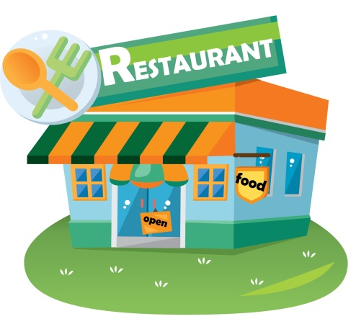If you think we are in the restaurant business, you are wrong! We are in the business of retail sales. We manufacture a variety of products and merchandise in our kitchen and bar. Then, we offer it for sale to customers in a display service area known as counter tops, tables, and dining rooms. Unlike most retail operations, such as department stores, our product has a limited shelf life, due to potential spoilage.

There is a greater sense of urgency for selling, moving, and serving our products. Our Restaurant is not merely a place to eat or drink, but rather a building designed to accommodate, facilitate, and promote the retail sales of food and beverage to customers through service. We provide service as a way of making sales to our guests.

|  |
| --- |
| To Serve Is to Sell |
| You don't buy coal; you buy heat |
| You don't buy glasses; you buy vision |
| You don't buy circus tickets; you buy thrills |
| You don't buy the paper; you buy the news |
| You don't buy dinner; you buy sales and service. |

### The Difference Between A Restaurant And Other Retail Sales Organizations:

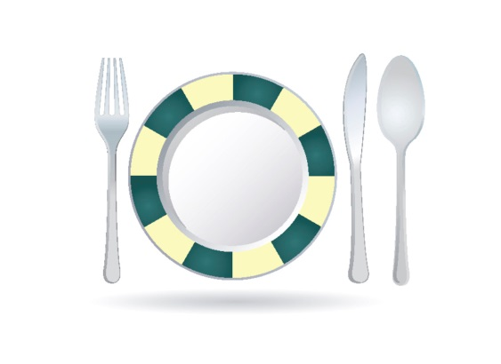In a restaurant, we manufacture AND sell our product under the same roof.

In a restaurant, we know our guests are here to buy, not browse (no one comes in to try on the pasta).

In a restaurant, our guests may return as many as three times a day (lunch, happy hour, and dinner). Although this is unlikely, some guests may be regulars, day after day. No one buys the same shoes, pants, or socks three days in a row.

Department stores provide service. Restaurants provide hospitality: a warm feeling from feeding both the body and the soul.

More entertainers open restaurants and bars than department stores. Why? Because this is showbiz!

**Our function as a *Restaurant* is to acquire and maintain business, to turn casual customers into loyal, repeat guests.**

### Five Basics Of Service Excellence:

Look at me.

Smile at me.

Talk to me.

Listen to me.

Thank me.

### Remember, Every Restaurant Owes Its Existence To Its Customers.

When a customer forms an opinion of any food establishment, service and food presentation stand-alone. No matter how beautiful the surroundings or how delicious the food; poor service will certainly ruin the entire dining experience.

When developing good service, promote these qualities: promptness, courtesy, good manners, enthusiasm, and teamwork. In short, project a professional attitude. Unless you attain this goal, you will not be able to provide the high quality of service we expect here at MLD**.**

Each time you service a table; our reputation rests in your hands. You have the power to influence the opinion of those people. If they are happy with you and your service, they will probably return. They may also recommend the restaurant to their friends. However, if they are not happy...

In order to be properly efficient, service people must be constantly aware of their customers' needs. Anticipate what they will want. Learn to read expressions and body language. If a customer is frantically rubber necking, waving his arms, or nodding, chances are he needs something. The more he must ask for service, the less enjoyable his evening will be. The tip he leaves you will reflect his feelings.

**You will be trained**, by our most experienced qualified people. The more attentive, enthusiastic, and patient you are, the sooner you will develop the work habits which make you an excellent server, capable of taking great care of our guests and be rewarded financially too.

**Servicing the public**, in any business, requires a vast amount of humility and patience. Always maintain a friendly, but professional attitude. If you need help, ASK FOR IT. Even if you become an excellent server, there will be times when you will get behind. Have enough consideration for your customers, and the house, to get assistance WHEN NECESSARY. Remember - Teamwork - no business can survive without it. We have provided you with a service manual. In it we have outlined some helpful suggestions to make your job here more profitable and enjoyable. These are the tools of your trade. Use them wisely and they will help you prosper.

**Arrive on time** for your shift properly dressed, with scrubbed hands and nails, pressed shirt, and clean shoes. If your appearance is sloppy, your performance will be sloppy. Your appearance, dress, posture, and expressions broadcast to everyone how you feel about YOU. Take pride in yourself, and others will be proud of you.

**Introduce yourself**. Customers want to know who is serving them: It is the added personal touch they enjoy. Also, if they have enjoyed their visit, they can request your station again. They might even tell their friends to ask for you. Call parties are the best tippers. In this manner, you can develop a following.

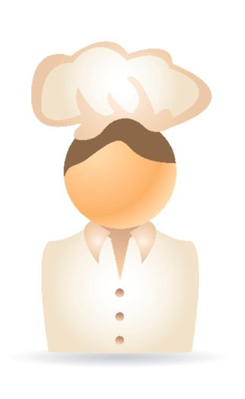**When people go out to eat, they want to relax**. They want you to help them decide what to eat, when to order, what to drink, etc. You are there to fulfill their needs. Don't be pushy; do be confident. Often a customer is nervous. It is your job to make guests feel comfortable, so comfortable they want to come back.

**Don't be afraid of customers.** 90% of the people dining out won't notice a small mistake. Be relaxed, but alert, and efficient. Always be in control of a situation. Be strong, yet polite.

**Always be yourself.** Develop your own tableside manner. Avoid using repetitious phrases or seeming "plastic." Your customers will know you are faking it, and they will resent your attitude.

### Customer Service Turn Offs:

Dirty plates in hand when greeting customers, "Hi, ready for dessert?"

Not knowing what they are drinking, i.e., "I think this is the Diet Coke..."

"Discussion Groups" of three or four idle servers. All discussions should be held in employee break area, during approved break period.

Not acknowledging waiting guests.

Answering the phone with "Hold please."

Greeting guests with a number, i.e., "Two?” instead of a smile and "Welcome! Will anyone be joining you for lunch today?"

## Waiting List Calls

If a customer calls and asks how long the wait is for a table, ask for how many are in their group and give them the approximate time. Offer the customer this service point, "If you would like to put your name on the list now, as long as you arrive within the specified time with your party complete, I can expedite getting you a table. Please check in with (your name) at the host stand when you arrive, so I know you are here. Thank you and I'll see you in _____ minutes." This is a service point we believe our customers will appreciate.

## Customer Complaints

Any time a customer has a complaint, always deal with them calmly and get a Manager immediately. This is important for complaints in person, as well as over the telephone. Our goal is to take a negative situation and make it a positive one. Apologize to the guest for any inconvenience, and get the Manager immediately.

## Diplomacy & Tact

Because your position at the door is semi-stationary, guests will look to you to solve problems: i.e., lost items, questions about the wait, their seating arrangements, the need for a taxi, etc. No matter how busy you are, each guest must be treated with sensitive concern for their problems or interests.

Tact and diplomacy under pressure is a skill essential to your success at the Unit. Your ability to smile and remain calm in the face of adversity will eliminate the stress encountered in your job. Often, the only solution to a problem will be to get a Manager. Do not hesitate to do this; however, most problems can be solved just by providing a listening ear.

## Bidding Farewell

You as a Host/Hostess are the guest's first and last impression of MLD. Just as your friendly smile and attitude welcomed the guest into the restaurant, your pleasant farewell leaves the guest feeling good and wanting to return.

We have four distinct objectives with every departing guest:

To make sure their experience in our Restaurant was pleasurable.

To thank them, by name, for their patronage.

To invite them back for another visit soon.

To make sure their last impression is a positive one.

Host staff, bussers, servers, and managers all have the responsibility to bid our departing guests farewell; but host staff and managers usually have the most frequent opportunities to do so. Here is the behavior associated with a farewell that is guaranteed to generate a repeat visit:

Help guests on with their jackets or coats.

Open the door for every departing guest.

Thank guests by name and invite them back for a specific occasion: "Come back and enjoy our (WEEKLY SPECIAL, NEW PROMOTION OR SPECIAL EVENT)"

It takes only a fleeting moment to wrap and deliver it, but the memory of it can last a lifetime. It's the only thing people can wear that never goes out of style. And, one size fits everyone. It is called a “**Smile**.”

# Alcohol Awareness

The Maple Leaf Diner is committed to serving alcohol responsibly. Managers and staff must take all reasonable steps to prevent underage drinking, alcohol over consumption and to prevent our guests from driving while under the influence of alcohol. The reputation of our restaurant is at stake.

## To serve or not to serve?

### Your Role:

Observe

Monitor

Report

### With Adherence To The Company's Policies...

We will not knowingly admit obviously intoxicated customers into the establishment.

We will not knowingly serve alcohol to an obviously intoxicated or underage customer.

Know and watch for the signs of intoxication. If there is any question, avoid further service and report to a manager who will make the final decision and determine whether the guest should remain or leave.

We will offer alternatives to alcohol.

We will create an atmosphere to promote responsible drinking.

We will make a reasonable attempt to prevent obviously intoxicated customers from driving.

**intoxication behavioral cues**

* **Inhibitions** – Becomes talkative, relaxed, over-friendly, loses self-control, and sometimes displays mood swings.
* **Judgment** – Behaves inappropriately, such as ordering doubles at last call, uses foul language, tells off-color jokes or annoys others.
* **Reactions** – Classy, unfocused eyes, talks or moves very slowly, forgets things, slurred speech.
* **Coordination** – Stumbles or sways, drops belongings, has trouble picking up a drink.

# Menu Knowledge

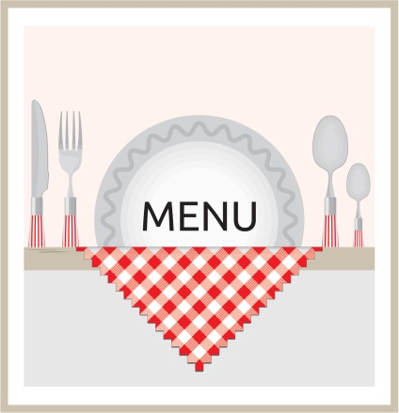During your training, you will be exposed to the menu and it's ingredients. It is imperative, as a Host/Hostess, which you know the menu items and the accompaniments that go with them. This will enable you to assist any guest with questions in person, or on the phone.

## Menu and Drink Prices

The prices will be listed on copies of the menu which you will keep at the Host stand. These prices may change, therefore, check with your Management team to stay informed.

## Specialties

The Maple Leaf Diner specializes in breakfast, lunch and dinner with a Canadian flare. Our signatures dishes included poutine and chicken-bacon-and-waffles among others. We are known for our abundant portions and eye-catching platters.

## Specials & Features Of The Day

Each day at pre-shift meetings, that day's Specials will be discussed.

### We Offer Daily Specials For Three Reasons:

To add variety to our menu

To allow our customers the best of seasonal items.

To allow us to test items for future menu development.

These specials may include a drink special, an appetizer, a salad, a pizza, an entree, or a dessert item.

# Performance Standards

We do not have "to-go cups" under any circumstances. No one may take any bottle or glass outside of the building.

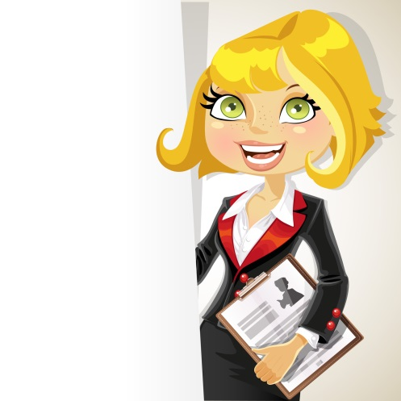We do not keep purses or any personal belongings for the customers. This includes employees when they are in on their off nights.

Advise a Manager of any customer who appears to be intoxicated.

IF YOU ASK TO LEAVE...YOU CLOSE.

If you fail to show up for a shift, you will meet with the General Manager prior to your next scheduled shift.

Notify a Manager of anything out of the ordinary, or any possible problem.

A smile and friendly attitude are part of everyone's uniform.

All employees are required to have a telephone number where they can be reached.

If you notice anything in the Restaurant that is broken or damaged, notify a Manager.

Do not leave your station on break without checking with a Manager.

Do not eat, drink, or smoke while on the floor.

You must be in your station working in completed uniform at your scheduled time.

All schedule changes must be approved by a Manager.

If you wish to continue to have a break area, keep it clean. Do not leave glasses, ashtrays, napkins, etc., laying out.

You must clock in and out as scheduled. BE ON TIME!

Print a copy of your schedule each week. Do not call up to the Restaurant to find out your schedule. You are responsible for knowing your schedule.

You may not receive personal phone calls at the Restaurant, except in a real emergency. Please inform your friends and family.

Schedule requests are due by the Wednesday prior to the Saturday posting. Leave them in the designated area.

You may not come into the back of the house after you have been drinking. You may not take alcoholic drinks into the break room.

If you have a suggestion on how to make the Restaurant run more efficiently, please give them to a Manager.

You will greet your guests with -

1. A smile
2. Your name
3. A welcome
4. Promotional information and specials

When your guests leave, you will thank them for coming and invite them back.

You will clean stations during your shift - EVERYTHING from floor to ceiling.

No more than two cigarette butts per ashtray. Cap them properly.

Teamwork is ESSENTIAL.

## Points of Difference

### The Telephone

We will answer the telephone within the first two rings, with a smile on our face and enthusiasm in our voice.

We will check back with guests on hold every 30 seconds.

### The Greeting

We will not use the host stand as a barrier.

We will make every guest feel wanted and appreciated.

We will greet our guests within 30 seconds upon their entry into the Restaurant.

We will shake hands and compliment our guests.

We will make sure the entryway to the Restaurant is always clean of all debris.

### Waiting List

If there is a wait, we will "sell" the wait, NOT challenge our guests.

We show enthusiasm and excitement with a wait, NOT irritability and stress.

### Seating The Guest

We will walk slowly and with the guest.

We will pull chairs out, whenever possible.

We will suggest specials or favorite menu items.

We will be "seating sensitive" to customers' needs: i.e., do not seat a romantic couple next to a family with children; do not seat a guest in a wheelchair in an aisle; make sure a Braille menu is given to a blind guest.

### Bidding Farewell

We will help all guests with their coats.

We will open the door when guests are leaving.

We will say "good bye" using guests' names.

We will invite all guests back for a specific occasion.

We will offer "to go" menus.

We will answer all questions from our guests, with concern and a smile.

## Front of the House Behavior

There is to be no yelling or arguing in the front of the house. If you have a problem with a customer, DO NOT ARGUE, keep calm, and get a manager. The same applies to employee relations. No yelling or arguing, - get a manager.

## Eating or Drinking

There is to be no eating or drinking in the front of the house at any time. Food is only to be eaten during management approved breaks in appropriately designed areas.

## After Shift Behavior

Employees may not sit with customers at a table or at the bar while in uniform. If you are visiting the restaurant off duty, you are still a representative of the company. For this and other reasons, we will appreciate you maintaining a very high standard of behavior.

## Opening, Running, Closing Duties

Every shift at the restaurant has opening, running, and closing duties. These duties are posted in the host/hostess bible. These duties are extremely important in assuring smooth daily operations and ongoing quality service. They require teamwork, and through teamwork, we will maintain excellence in service.

Opening and closing duties will not be considered complete until approved by the manager on duty. Running duties refer to ongoing duties while the Restaurant is open for business. The responsibility of making sure these duties are being done during the shift, is that of you and your teammates. **Each station is assigned its own duties. Some duties will require individual effort, while others will require team effort.**

# Additional Host/Hostess Information

## Paging System

If there is an emergency phone call for a guest, get an accurate description of that individual so that you can physically look for them in the Restaurant and bar area. Notify the Manager for assistance.

It may be necessary to call the party’s name with a loud, clear voice; all the while offering a smile. At MLD we do not page, we use personal descriptions to identify a specific party and person.

Be certain the customer has closed out their bar tab, prior to escorting them to their table. If they wish to transfer their tab to the table, we will be happy to do so.

## Promotions

Be aware of all current and upcoming in-house promotions. Your Management team will remind you of current promotions and inform you of upcoming promotions during the daily pre-shift meetings. Advertising brings the product to the consumer; promotion brings the guest to the product. We have found that our sales volume increases when special promotions occur. We expect all staff to promote all activities with enthusiasm. Our biggest return should be from word-of-mouth through our staff.

An example of an in-house promotion would be our Daily Happy Hour. As a Host/Hostess you may recognize a regular dinner customer and inquire if they have ever visited our restaurant at Happy Hour when food and beverage discounts are featured. When that guest leaves after dinner, thank them by name and invite them to return on another occasion. You have just successfully completed the "Sell to Sell Again" creed of our Restaurant. You enrolled a customer into an activity that day, and encouraged them to participate in an upcoming promotional activity. You, through your knowledge of in-house promotions, have just increased our sales potential.

## Lost And Found

All items found are turned into a Manager and immediately listed in the Lost and Found Log. Items are then placed in the Lost and Found area in the back office, as soon as possible, by the Manager.

During operating hours, any inquiries made by a guest, regarding lost items, should be directed to the front door. A Manager or Host/Hostess will list any guest with a report of a lost item, along with its description, in the Lost and Found Log. This log should be returned to the back office at the end of the night.

The log is kept at the host stand. The opening Host/Hostess will pick up the log at the beginning of the shift, so that they may answer and record inquiries. Articles found in the facility are kept in the Managers’ office for two weeks; and, if not claimed, they will then be donated to a charitable organization.

## Tipping

Tips are never, under any circumstances, accepted by any Host personnel, Management and staff alike, for preferred seating placement in waiting lines or any other such "favors." When tips are offered for other services requested at the door, such as passing messages, the tips are graciously refused and the services requested by the guest are performed in the normal course of serving our guests.

# Conclusion

There is a lot of information contained in this manual! Believe it or not, however, there is even more information that is not.

We have given you the basics, as we view them, and how we would like them to be conducted. There is no section in this manual concerning "Teamwork." The reason for this is that we feel this topic falls under the "Common Sense" category. We expect the host staff at MLD to possess this common sense from the word "GO."

We want you to use the service tips in the manual, along with your common sense, and above all, YOUR individuality, to help create an atmosphere that will encourage good times for our customers, and yourself. If this happens, you will be ensuring the success of not only the Maple Leaf Diner, but also yourself.

GOOD LUCK!!!

