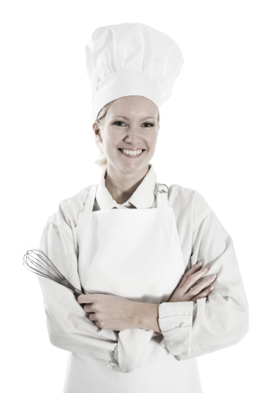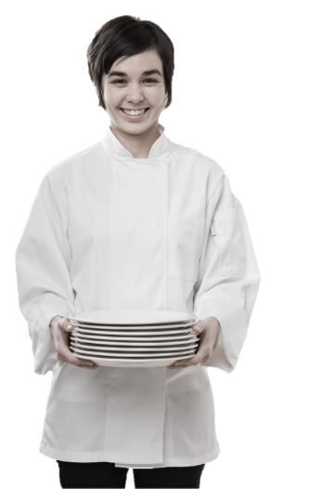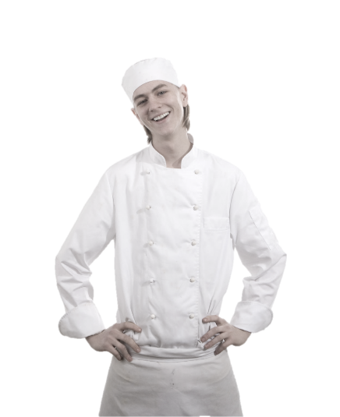

Standard Operating Procedures

**Server**

**Training Manual**

**2019**

**Employment Policies and Procedures**

Table of Contents

Introduction

General Job Guidelines & Responsibilities

* Server Opening Procedures
* Server Closing Procedures

Guest Care

* Never Underestimate the Importance of a Guest
* You Must Be Able To Serve Many Different Types Of Guests
* Five Basics of Service Excellence: From the Perspective of the Guest
* Customer Service Turn Offs

service

* What is Important to Every Guest
* Extraordinary Service With a SMILE
* Keys to Service Excellence
* The Finer Points

Customer complaints

* Procedure for Handling Complaints
* PLEASE Approach

Quality Control

* Things to look for before leaving the kitchen

Server mechanics

* Serving Basics
* Ordering Procedures
* Hand-Writing Orders
* Cooking Times & Handling Timing Problems

Personal Appearance

* Uniform
* Dining Room Dress Code

Suggestive Selling

Specials & Features Of The Day

Coffee - Tea - Desserts

Wine Service

* VARIATIONS

Closing Out A Table

* Presenting the Check
* The Farewell
* Methods of Payment

Check-Out Procedures

* Before You Start the Paperwork Process
* Accountability Process
* Gift Certificates
* Cash
* Zeroing Totals
* Time Out
* Tip Declarations

Alcohol Awareness

* The Law
* Intoxication Behavioral Cues
* Identification Request or "Carding"
* Acceptable Forms of ID
* Steps To Checking ID

Safety & Sanitation

* General Policy
* Beverage Service

Conclusion

# Introduction

Congratulations on being selected to perform one of the most important, challenging and rewarding jobs at the Maple Leaf Diner!

As a Server, you will set the stage and have a direct impact on each guest's experience. You will determine whether each guest feels welcome, appreciated and well cared for.

We will provide you with the training you need to be successful. We take great pride in our quality food and friendly, responsive service. Our high standards can only be maintained through great people like you who share our values and desire to do the very best job possible for our guests every day.

As a server, it is essential that you maintain an energetic, friendly and caring attitude at all times. It is your responsibility to see that each guest is made to feel special and enjoys our fun atmosphere and great food and beverages.

The guidelines listed on the following pages have been established to help you in your effort to provide these qualities to our guests. Along with the hands-on training you will receive, this manual will provide answers to questions you may have regarding your tasks, responsibilities and operating procedures.

Once again, welcome to the Eh-Team!

# General Job Guidelines & Responsibilities

The following points are general responsibilites that are specific to being a server. The complete responsibilities and standards expected of an employee can be found in the **Employee Handbook**.

* **Know** your schedule.
* **Know** what time to be here for each shift.
* **Know** what the daily specials are and what they cost.
* **Know** the history of the restaurant.
* **Clear your mind of everything except work when you walk in the door.** When you're at the table make sure your mind is at the table too. Guests can tell when their server is not totally mentally present with them at the table and it has a negative impact on the guests' experience and the server's tip.
* **If you get behind, ask for assistance. You'll never get in trouble for asking.**
* **Keep yourself geared up so that you are ready for any rush.** We get most of our complaints during the Restaurant's slow period.
* **Don't ever stand around or lean on anything.** You can always be cleaning. Running clean-up, wiping shelves or the sales station, taking bus tubs to the back, etc. A server never goes into, or leaves, the kitchen empty handed. Full hands in, full hands out!
* **Never** attempt to adjust the lights or thermostats in the restaurant. If there is a problem, get a manager.

## Server Opening Procedures

### At The Beginning Of Each Shift

1. Attend to all essentials (restroom, uniform adjustments, grooming) before work.
2. Clock in no sooner than 5 minutes before the start of your shift unless told otherwise from a manager.
3. Check your station assignments.
4. Check the Daily Service Board for specials, soup of the day, "86'd" items, etc.
5. Conduct your station check points

* Tables wiped
* Clean window sills
* Table base clean
* Chairs wiped
* Condiment containers clean and full
* Salt and pepper shakers clean and full
* Floor clean

1. Perform opening sidework - (wrapping silverware, making tea, cutting lemons)

## Server Closing Procedures

### At The End Of Each Shift

1. When station closes, perform the following –

* Wipe tables
* Clean chairs - seats, backs and legs
* Wipe window sills
* Clean table bases
* Condiment containers clean and full
* Sales & pepper shakers clean and full
* Clean floor

1. Complete assigned closing side work duties
2. Begin check-out procedures
3. Clock out

**Server Functions & Responsibilities**

Successful sales and service result from confidence, which can only be developed through knowledge. We will provide you with ample material to develop the necessary knowledge and confidence in relation to service techniques, the menu and the wine list. You, as a server for MLD, must learn it.

**General Service functions And Responsibilities**

* **Never** handle a glass by the rim with your hand over the drinking surface.
* **Never** handle silverware with your hand over the eating surface.
* When handling plates or food, **never** let your hand touch the eating surface or the food.
* **Don't hide from your customers.** If you use this method in taking orders, you will find that your food will be out more consistently on time, and you will give much better service over all. You will have more time to converse with your customers. People look for more than just good service and food when they go out today. *They want a total dining experience.* They look for that little extra personal touch which only you as their server can give them. **Never spend more than two minutes away from your station.** No server ever made any money in the kitchen.
* **Always** be sure that all your food is secure when you leave the kitchen. **Never** attempt to carry too much. Two safe trips are better than one catastrophe.
* **If an order is delayed in the kitchen, first inform the manager, and then tell your customers.** The manager will go to the table and explain the situation as well. Get your stories straight. Never hide from your customers.
* **Learn to use your time wisely.** When in your station, check all the tables before going back to the kitchen. Don't go to one table then go to the kitchen. Consolidate your trips. Fill up all glasses in your whole station, clear all plates, and then go on to something else. This is the secret to running volume and making more money.
* **If one person asks for something at a table, make sure you ask everyone at the table if they too would like that item.** This will save you a lot of extra trips. If one person requests more tea, ask everyone at the table if they need more tea.
* When serving coffee or hot tea, **always** turn the coffee cup so the handle is facing the customer. Place the cup on the right side. Ask people if they would like cream when they place their order for coffee instead of making an extra trip later.
* When pouring tea or water, **never** handle the rim of the glass and always take the glass off the table and pour in the aisle.
* **Always** keep your fingers and thumb off the plates you serve.
* **The customer is NOT required to tip.** If you get stiffed, it is unfortunate, but you must take the good with the bad. Any customer feedback about an employee regarding a bad tip will not be tolerated and is grounds for immediate dismissal.
* **When waiting on parties of one, or an ace as they are called in the restaurant business, special attention should be paid to them.** They are generally in and out quicker than other parties, and they are usually the best percentage tippers.
* **People who come in the last few minutes of the evening are usually the best tippers.** They don't care how busy it was or how tired you are. They are here to enjoy themselves. Restaurants are noted for hurrying along late coming customers. We are not rushing them, but we must get their order because the kitchen is closing. They may sit there and enjoy their meal as long as they wish. Treat them as though they are the first customers of the evening.
* A tip should **never** be removed from a table while the customer is still there. Unless, however, the customer hands it to you or motions for you to come and get it.
* **If you must go to the bathroom** during the shift, ask someone if they will please watch your station while you are gone, and inform a manager so that they are not looking for you.
* **No server** is to change his or her station or pick up extra tables without the consent of the manager on duty.
* **Never** serve a salad on hot plates.
* **Always** check your glassware for cracks and dried food before filling them.
* **Serve food** from customer's **left**.
* **Serve beverage** from customer's **right**.
* **Clear everything** from customer's **right**.
* **Serve women and children first**, then men.
* 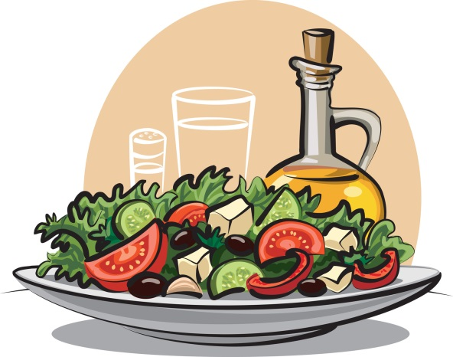Whenever you serve a course, ask if there is anything else you can do for the table.
* Whenever serving a course, **position the plate so that the "meat" of the course is closest to the customer.**
* Remove soiled china and silver after each course.
* Top off with offer of additional beverages whenever anyone is getting low.
* Bring condiments to the table **before they are needed.**
* Offer fresh ground pepper with **all** salads.
* **Never** walk away from a table without acknowledging its requests.
* **Help your guests as much as possible.**

# Guest Care

***Our function as a Restaurant is to acquire and maintain business, and to turn casual customers into loyal, repeat guests.***

## Never underestimate the importance of a guest!

A guest is not dependent upon us -- we are dependent upon him (or her).

A guest is NEVER an interruption of our work - he is the purpose of it.

A guest is the lifeblood of our restaurant.

### Five Basics Of Service Excellence: From the Perspective of the guest

Look at me.

Smile at me.

Talk to me.

Listen to me.

Thank me.

### Customer Service Turn Offs:

Dirty plates in hand when greeting customers, "Hi, ready for dessert?"

Not knowing what they are drinking, i.e., "I think this is the Diet Coke..."

"Discussion Groups" of three or four idle servers. All discussions should be held in employee break area, during approved break period.

Not acknowledging waiting guests.

## You Must Be Able To Serve Many Different Types Of Guests

To make appropriate selling suggestions, and give good service, it is helpful to recognize and know how to handle all types of guests. For example:

|  |  |
| --- | --- |
| The Timid Guest: | Genuine interest and patient understanding will put this type of guest at ease. Even a comment on the weather can make him feel at home. |
| The Aggressive Guest: | This type must be handled in a courteous and businesslike manner. Kindness and politeness can often change him into a steady and appreciative customer. |
| The Fussy Guest: | This is one of the hardest guests to please. Try to stay one step ahead of him by learning the things that irritate him. Be sure to have everything just right, before serving the fussy guest. Remember all of the little things the fussy guest especially likes, even when they may seem peculiar to the average person. |
| *The Over-Familiar Guest:* | *Be courteous, dignified, and avoid long conversations. Stay away from the table, except when actual service is needed. Never try to give a wise crack answer to a smart remark. You will only cheapen yourself and lower yourself to the same level as the rudeness of the guest.* |
| The Guest Who Is Alone: | Don't call attention by asking if he is alone. Seat him where he can see what is going on. The guest may be lonely and want someone to talk to. Be friendly, but don't neglect other guests. With nobody to talk to, time seems long, so serve as quickly as possible. This could be your most critical guest. |
| *The Noisy Trouble-Maker:* | *Don't be drawn into arguments. Speak softly. Don't antagonize. Refuse to participate in criticism of management, the establishment, or other personnel.* |
| The Blind Guest: | Seat blind people with a dog so that the dog will not be noticed. Never hover over blind customers. Always stand near enough to help if needed. Issue menus in Braille to the blind guest. Always make a blind customer feel appreciated and important. |
| *Guest With Hand Or Arm Injuries/Disability:* | *Seat as quickly as possible. Be helpful, ask if you may assist them, but do not be too eager. Be considerate; do not call attention by hovering. Seat wheelchair guests at a table on ground level do not block an aisle. Always make a disabled guest feel important and accommodated.* |

**Service**

We pride ourselves on a superior level of service, and a heightened sense of pride and teamwork, that results in absolute guest satisfaction. We are passionate about providing service that goes above and beyond the expectations of our guests. Our spirit of service is centered in treating every guest as we would like to be treated.

**What is important to EVERY guest?**

* **Value** – Exceed guests’ expectations; make them feel good about their decision to dine with us.
* **Quality** – uphold our high standards with sincere efforts to assure our guests they have made the right choice.
* **Energy** – Welcome our guests with a bright, warm smile that conveys the message “I’m glad you’re here.”
* **Prompt** **Service** – Provide what our guests need quickly to ensure a great dining experience. Anticipate needs before guests ask and never make guests wait to pay.
* **Entertainment** – Make the dining experience memorable and festive. Have fund with our guests; add your personality into each step of service.
* **Emotional** **Entertainment** – Guests remember how we make them fee. Treat guests like family and show you care with your gracious hospitality.
* **Acknowledged** **–** **Recognized** **–** **Welcomed** – Thank our guests; show them sincere gratitude for choosing us and make them want to return again and again.

**Extraordinary service with a s.m.i.l.e.**

**Show Sincerity** – Sincerity is the true desire to please, a strong effort to know and understand the needs of your guests. It requires active, focused listening, a pro-active mind and flexibility of approach. It demands that you truly enjoy working with and pleasing people.

**Manage It** – Good service does not happen all by itself; it must be managed on a daily basis. That means walking your talk and demonstrating what service really means to you.

**Individualize** It – Every one of our guests has a different definition of service, so you must listen and be flexible to satisfy everyone’s needs. The best way to learn your guests’ expectations is to ask them yourself. Show a sincere interest in their experience with you.

**Lead by Example** – We have created systems and procedures to help us ensure guest satisfaction consistently. You need to be a standard-bearer for these systems and share your knowledge with new staff members.

**Engage** – Keep your guests in mind at all times. Treat guests as you would want to be treated.

**Keys to Service excellence**

A recent survey of 700 diners revealed what they look for in an exceptional dining experience:

1. **Good Manners** – Words matter! Use please, thank you, polite forms of address: sir, ma’am, ladies, ladies, gentlemen. Focus on the needs of the guest – not your own.
2. **Knowledgeable Staff** – Help guests find THE dish that they will love! Give enthusiastic and vivid descriptions of the menu items. Offer suggestions and tourguide to ensure guests get what they expect.
3. **Attentive Service** – Anticipate guests’ needs. Offer or bring needed items BEFORE your guest even has to ask!
4. **Appropriate Pace** – Guests are able to dine at a pace they desire and are invited to enjoy our dessert and coffee.
5. **Guest Check Etiquette** – Promptly present guest checks and return without any questions about change. Collect tips after guests depart.
6. **Good Grooming / Hygiene** – Look the part! Arrive at work with neat hair and attire.
7. **Consistent Service** – Whether it is our delicious food or excellent service, guests, who have enjoyed a memorable experience with us, will come to always expect it form all of our staff at every location.

**The finer points**

**EXCEPTIONAL Service is:**

* Seamless / fluid
* Memorable
* Pleasantly surprising

**The Staff are:**

* Experts and guides
* Gracious and hospitable
* One step ahead of the guest

**GOOD Service is:**

* Efficient
* Pleasant
* Enjoyable

**The Staff are:**

* Knowledgeable
* Polite
* Prompt

# Customer Complaints

Nobody enjoys being the recipient of customer complaints, but complaints are to be expected as part of being in the hospitality business. Complaints can even be viewed in a positive light if they are handled properly. Complaints can give us insights as to how to make our Restaurant better, demanding customers force us to be our best and resolving complaints satisfactorily can even increase customer loyalty IF they are handled properly.

**Procedure for Handling Complaints**

When faced with a customer complain:

1. Don’t get defensive and try to explain.
2. Remove the offending item immediately.
3. Apologize for the problem and tell the customer you will take care of the problem.
4. Report the problem to a manager on duty.

Do everything you can to let the customer know you care and that this isn’t the kind of experience you want them to have at our restaurant.

**The P.L.E.A.S.E. Approach**

This approach reminds us to open-minded, attentive, respectful, and kind when interacting with others or solving an issue. Once we understand the other person’s view, we can apologize and do everything in our power to make things right and show we care.

**Positively Approach** – Connect instantly through friendly body language, open expression and a warm tone of voice. Clearly communicate your willing ness to resolve the situation. Show that you’re on the same side and here to help. Be proactive: look for opportunities to interact.

**Listen Actively** – Show you’re listening. Nod or shake your head, “Oh no”, “Hmmm.” Wrinkle or raise your brows. Make eye contact – be attentive and respectful. This is not the time to solve or defend – just listen and let them tell their story. By “listening between the lines,” you gather more information and begin to understand what the person really needs.

**Empathize** – Everyone wants to be understood. Imagine yourself in their situation and withhold judgment. Don’t explain or justify – instead, acknowledge and validate their feelings. “I know it’s especially difficult to wait so long when you have small children. Can I bring you some bread or juice for the kids?”

**Apologize and Ask** – If we made a mistake, admit it! Say you’re sorry for the specific error or problem. It’s kind to apologize even if it was only a misunderstanding. “I’m sorry we let you down.” “I’m very sorry your experience wasn’t perfect.” Then, ask the right questions – without interrogating – and figure out what really matters to that person.

**Solve** – Effective problem-solving restores trust and builds loyalty. Think creatively to find the best solution, and then do the right thing! Solve the person, not just the problem. Think outside the box and make it a win-win. Own the entire solution an personally follow up. “our bartender knows a lot about wine. May I ask what she suggests?” then follow up, “Are you enjoying this wine more?”

**Engage and Thank** – How we end a conversation leaves a lasting impression. Show appreciation and encourage feedback. “Anytime you have a question about the menu, just ask!”

# Quality Control

Quality control is a primary responsibility of every employee serving food and drinks to the customer. You are the last person to come in contact with the food before the customer does. If something does not look right or is not presentable, DO NOT SERVE IT! The saying "People eat with their eyes" is very true. Make sure all of your products look good on the plates.

## Things to look for before leaving the kitchen:

1. **HOT food**. Few things are more basic but more important. Check to see of your food is hot. Just because something is in the window, does not mean that it is hot. If it is not hot, DO NOT TAKE IT OUT. Tell the manager. NEVER yell or argue with a cook. Go directly to the manager. This will alleviate a lot of problems.
2. **Clean plates**. Always check any plates, mugs, silverware, and napkins before you present them to the customer. Check food basket for grease spots, spilled food, etc.
3. 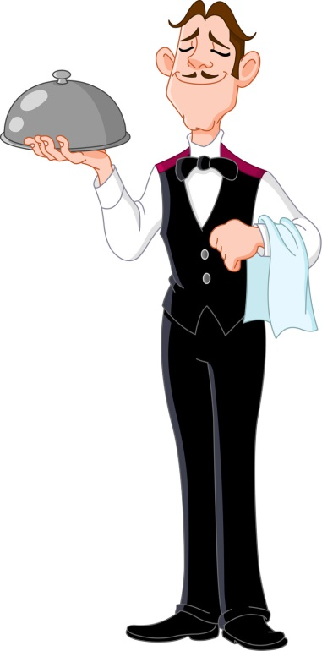**Correct portions**. Always check to see that the product is in the right portions. Make sure you are taking YOUR order. This can be very embarrassing at the table. Always ask yourself if you would eat that item if it were brought to you.
4. **Call for back-ups**. If something in the kitchen looks low and you are about to run out, TELL SOMEONE. If you take one of the last bowls of soup, call for back-ups. If the salad is warm or wilted, do everyone a favor, and say something before the customer is served.
5. **When bringing out drinks**, be certain the glass is clean, filled to the proper level, and that the garnish is correct, fresh and attractive.
6. **Cold food** **is as equally important as hot food**. Make sure cold foods are going out cold, not warm or cool, but cold.
7. **Bring necessary condiments with order**: i.e., ketchup, mustard, Parmesan cheese, etc.
8. **Check back** . . . within two bites to make sure everything is perfect. Don't say, "Is everything o.k.?" Guests here this trite saying so often it's meaningless. Say something like, "How's your filet cooked?" Be specific and sincere in wanting to know the answer.
9. 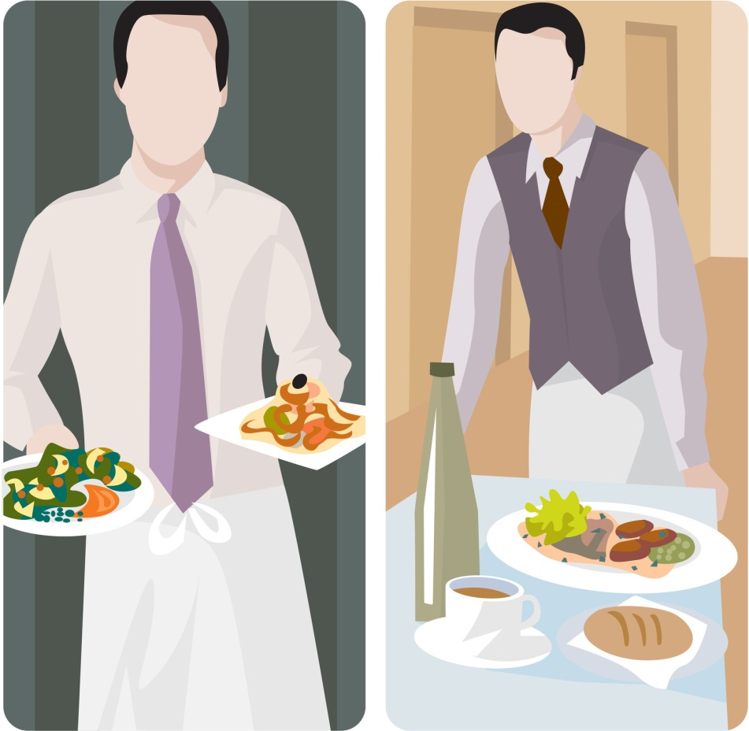**If the customer is not satisfied** . . . or there is obviously something wrong at the table, i.e., cracked glass, foreign object in food, not cooked properly, etc., use the following steps:

Apologize.

Remove the items immediately.

Get a manager. Management will take the necessary steps in making sure that the problem is corrected and that the customer is 100% satisfied.

1. Remember, the appearance of the exterior of the building, the greeting of the host, the cleanliness of the restrooms, the appearance of the staff, the quenching taste of our beverages, the flavor and freshness of our food, are all equal quality points. **WE must control for the experience of our guests.**

# Server Mechanics

## Serving basics

**CRITICALLY IMPORTANT!!** - **Immediately acknowledge all new parties in your section.** Regardless of how busy you are; you are never too busy to let your customers know you see them. They come here to be taken care of, so don't start out their dining experience by ignoring them. All new customers should be greeted within one minute.

If your hands are full, the customer knows automatically that you can't take their order, at that minute. You can pause, smile, and say "Hi, I'll be with you in just a minute." This will satisfy the customer so that they feel important and will be able to relax until you return.

When approaching a table your objective is to make you guests feel welcome and confident in knowing you're there to take care of them. You may develop your style and manner of accomplishing this but here are some suggestions to help you get started:

1. **Start out by giving your name**. Make them feel welcome; that they've made a good decision to be at our restaurant and give them a sense they're in friendly, competent hands. Be observant, not scripted. It's o.k. to pay someone at the table a sincere compliment or try to open up some friendly rapport.
2. **After delivering food to the table**, give the customer a few minutes to try the dish, and then return to the *table. "How is your steak cooked? Can I get you another...Scotch and water, ice tea?"*

When checking on food items, always accentuate the positive, and eliminate the negative. Do ask, *"Did you like the way your steak was cooked?”* Don't ask, *"Was everything ok tonight?"* Ask an intelligent, specific question and show you're concerned about the answer you get. If something isn't right, do what you can make it right.

1. **Each time you take an order**, be aware of what might elevate the guests' experience. Be relaxed and friendly, polite and professional. Have an idea what extras (appetizers, sides, etc.) you are going to suggest based upon what you genuinely think will enhance your guest's dining experience. Allow the customers to finish ordering before you jump in with suggestions. If they hesitate, then it's your turn. *"May I suggest the (POPULAR MENU ITEM)? It's a one of our most popular dishes."* If they still hesitate, you might say something like, *"Would you like to have a little longer to decide? Take your time and let me know if I can answer any questions."*
2. **Know everything on the menu** in terms of what is in it, and what would go well with it. This will be covered in detail in your initial training and will be enforced often in our pre-shift meetings.
3. **Suggest premium liquor** in all cocktails. It makes the drink taste better, servers are tipped more, and when the guest drinks better, the server drinks better.
4. **Get your guests' drinks** to them within five minutes from taking the order; no longer.
5. **Suggest specific appetizers** before you leave the table to get their first drinks. It saves you time and steps.
6. **Learn and use guests' names** when appropriate.
7. **Make specific suggestions** at every step of the meal if you think it's appropriate: drinks, appetizers, sides, wine, desserts, after-dinner drinks. Always keep in mind, your first objective is to show your guests a marvelous time, not PUMP UP THE CHECK. Use your best judgment here. Sure we want to sell, but more importantly, we want our guests to leave delighted so they RETURN!

## Ordering Procedures

When approaching the table, be sure to have your pen ready, book open, and pad ready. Ask the customer if they have any questions concerning either the specials or entrees. After answering all the questions, if there are any, ask if you can take their order.

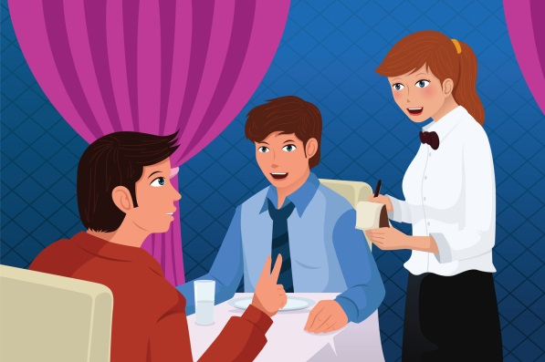Through either eye contact or verbal address, you may start to take their order. Be sure to gather all information from each guest before proceeding to the next. If possible, you should take the order from women and children first, and then the men.

**Apply the pivot point order taking technique.** In this technique, there is one point in the restaurant that acts as your landmark when taking your orders. Using this landmark, you can number each seat in a clockwise direction around the table to identify your customers and their orders. (Ex. Using the north wall as your “landmark” or “pivot point”, number the seats around the table starting with number 1 being the closest seat in position to the pivot point. Continue numbering table seats consistently.)

The reason is that we need to know who gets what. This technique keeps orders organized and consistent. We use a runner system, so there's a good chance someone other than you will be delivering the food to the table. The runner must know where to place the food without asking.

Begin taking the order at the same spot at each table. Start with the person closest to you on your left, and work around clockwise.

Example:

Pivot Point

|  |  |  |
| --- | --- | --- |
| 2 |  | 3 |
| 1 | 4 |
|  | **YOU** |  |

Taking the order is the time for making recommendations. Suggest appetizers that will complement the guests' meal. This is when wine can, and should, be offered.

**Hand-writing Orders**

In case of registers malfunctioning, follow these steps:

1. Write appetizers at top of ticket.
2. Write entrees under appetizers on the left, and how to cook them on the right of check.
3. For special orders like rare, be certain to make a notation on the ticket, to call special attention to the cooks.
4. Use the simple and understandable abbreviations.
5. Write all side orders underneath entrees.
6. Write desserts underneath side orders.
7. At very bottom of ticket, put all teas, coffee, milk, and sodas.
8. Bar beverages will be listed on the back of the guest check only.
9. After all items have been totaled, circle the total. This way, there will be no mistake of where the total is. Also, write thank you, your name, and have a nice evening, enjoyed having you (etc.).

## Cooking Times & Handling Timing Problems

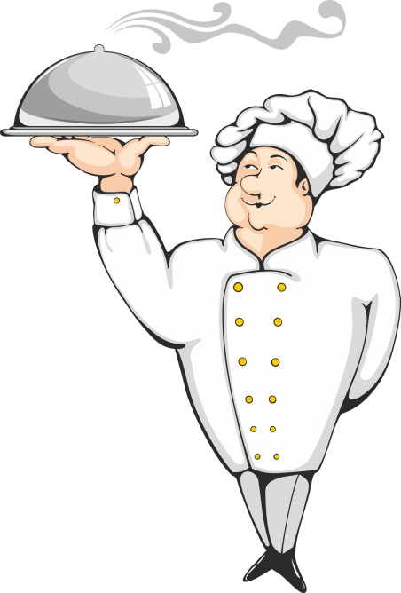Your tables' experience is dependent upon your awareness and service to the customers from the time they are seated; to the time they receive their order. If, by chance, you have a long time ticket, do not hide from your table. Notify a manager immediately, and we will expedite the situation.

When a table has to wait longer than they should for their food, don't just apologize, offer them something for the inconvenience. It costs us hundreds of marketing dollars to attract new customers; we can't afford to lose any. A complimentary beverage or dessert is a small price to pay to let a guest know we care about their experience and we want them to come back and give us another chance to get it right.

In cases where the kitchen has been woefully out of sync, a dessert or beverage may not be sufficient. Tell the manager-on-duty about the situation. They have the authority to do whatever is needed to try to make amends for a bad-dining experience.

# Personal Appearance

**Your overall image is our image.** You make a distinct impression on each of our guests. The image you create can enhance or detract from our overall concept and the way our Restaurant is perceived in the minds of the guest. You are entrusted with handling our guests' needs and must, therefore, reflect cleanliness and wholesomeness at all times. Always remember . . .

You are responsible for keeping your uniform neat and clean at all times. There is no excuse for reporting to work out of uniform.

A smile is part of your uniform.

Do not report to work with an un-pressed or dirty uniform, or un-kept hair.

## Uniform

When you walk through the front door of the Restaurant, "YOU ARE ON.” You will be informed of the uniform requirements when you start with us. Your designated uniform also includes a CONTAGIOUS, ENTHUSIASTIC ATTITUDE. You are required to enter the building for your shift in FULL UNIFORM. You are also required, when you leave the building, to be in FULL UNIFORM.

**Dining Room Dress Code**

**Shoes** – Clean solid black shoes (no colored stripes or logos) designated by the manufacturer to be slip-resistant or skid resistant. Must be closed toe and closed heel (no clogs). Socks must be black.

**Pants & Belts** – Clean professional looking, wrinkle-free black slacks / pants (dry cleaning / creases not required). Pants must be long enough to cover shoe tops. Lycra / polyester stretch knit, corduroy and linen pants are not acceptable and may not be worn. No rolled cuffs and no large pockets. Black belt or no belt.

**Shirts** – All shirts must be clean and wrinkle free. Black Maple Leaf Diner T-shirt or solid black t-shirt that is not faded and at least medium-weight material. The material must be thick enough, so it is not transparent.

**Accessories** - No cologne or perfume No excessive make-up or jewelry. No earrings longer than 1 inch. No hats.

**Apron** – Maple Leaf aprons must be purchased for $15.

**Miscellaneous** – Please have a wine opener, lighter and at least 2 pens at all times.

# Suggestive Selling

People don't like to be "SOLD." Effective suggestive selling is subtle. You are doing the guest a favor, looking after his best interests by offering your knowledge and expertise and making honest recommendations.

Many of our guests are not familiar with our daily specials. As their intermediary, you are in the position to smooth the way for a confused guest. Above all, be sincere and honest. Always do what you truly believe is in the "guest's" best interest. Recommend items you know are superior and you are certain they will enjoy.

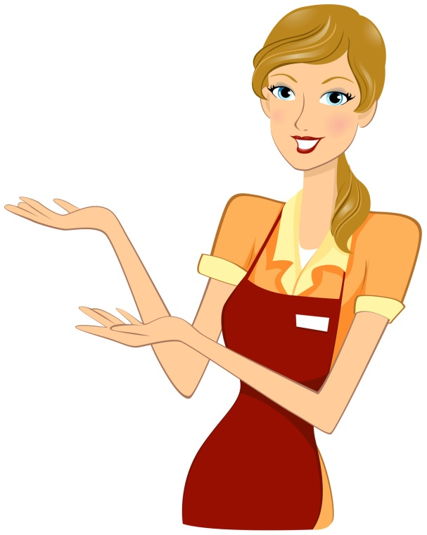NEVER OVER SELL! Always allow the guest to finish ordering before you start suggesting. Be aware of what the guest is ordering and make sure he understands what he is getting.

If a guest orders too much, and you are certain he can't handle that much food, advise him. He will appreciate your concern and honesty.

Suggest appetizers while people are studying the menu. "How about some Crawfish Cakes or sharing a spicy Cajun Shrimp Quesadilla," with your dinner this evening?"

Suggest side orders with entrees. "Would you care for seafood gumbo or a side salad with your Tabasco Filet?"

Always be persuasive and display complete confidence. Make suggestions so positively, that the guest wouldn't dream of questioning your recommendation.

Don't ask the guest a "yes or no" question. This requires him to make a decision. Remember, people come here to relax, not think. If you display confidence and complete product knowledge, the guest will trust your judgment and allow you to take care of him.

To sell effectively, you must sometimes bring a need or desire to try something to the surface. Make sure you use the right type of language.

For example:

|  |
| --- |
| "Would you like some wine tonight?" |
| If the guest responds, "No," your suggestion is over before it got started. |
| "Would you care for a bottle of wine with your dinner tonight? A bottle of Merlot would complement your Filet and Grilled Salmon." |

With this approach, you have exhibited your knowledge and confidence of food and wine by suggesting a specific bottle of wine. The guest has now developed confidence in you. This will greatly enhance your opportunity to make this sale and make other recommendations.

Not every guest is going to buy a bottle of wine, appetizer, or dessert. But you must remember, we know two facts about every customer.

Every Customer:

Is planning to spend money.

Wants to have a good time and enjoy their meal.

If you keep these two facts in mind, you will be amazed at how easy it is to sell, providing, of course, you possess the necessary knowledge and confidence.

Through suggestive selling you can:

Increase check totals. The higher the check, the better your chances of a good gratuity.

Expose the customer to a new and different product he may not have tried, if you had not recommended it. Thus, the evening is more enjoyable, and he may return with friends and has more reasons to tell others about our restaurant.

Suggestive selling and making personal recommendations is another aspect of good service. Eventually, it will come easily as you build your self-confidence.

# Specials & Features of The Day

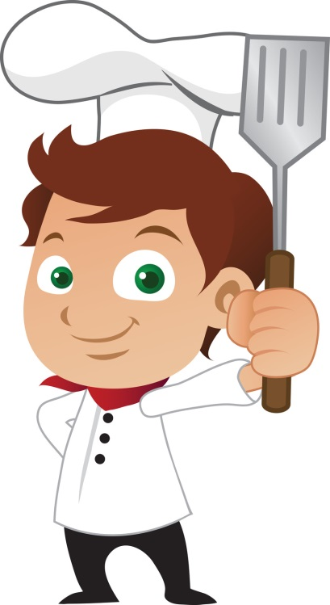Each day at pre-shift meetings, that day's Specials will be discussed.

We offer daily specials for three reasons:

1. To add variety to our menu
2. To allow our customers the best of seasonal items.
3. To allow us to test items for future menu development.

These specials may include a drink special, an appetizer, a salad, a pizza, an entree, or a dessert item.

In addition to placing a "special" card on the table, you as the server will present the "specials" verbally. This enables you to describe them thoroughly and answer any questions the customer may have.

When presenting the specials, you should start with drink specials, then appetizers, soups, and entrees. In describing the specials, you must use adjectives, which will entice the customers.

|  |
| --- |
| Bad Example |
| "Tonight we have New York strip with Vegetable Medley." |

|  |
| --- |
| Good Example |
| "Featured this evening is the tender New York Strip, wood-fired and served with fresh sautéed vegetables. The blend of hickory and oak add to the flavor of the juicy steak, complimented by the crisp combination of broccoli, cauliflower, carrots and squash." |

It is obvious which of these descriptions sounds more appetizing and it reflects your confidence in the special. If you are not sure which adjectives you should use, ask your fellow sales staff or manager on duty how they would describe the special. You may find that incorporating others' verbiage helps your special descriptions sound appealing.

# Coffee - Tea - Desserts

## Coffee & Tea

The wait staff serves coffee and tea. If you are busy, you may instruct the busser to help you out.

Tea service will be done on a verbal basis. When a customer orders tea, you will tell them the teas we have, and serve it to them. There is no charge for refills of coffee or tea, even if a new tea bag is served.

## Desserts

The dessert menu, including specialty coffees, desserts, and dessert drinks, are presented at the table and verbally described.

**It is a good time to remind guests to save room for dessert, when you return to their table to check on the entrees.** At this time, you may want to suggest a few dessert items, to plant the thought. Later, when clearing the table, ask your guests if they are ready to try dessert. You can then begin to describe a few of your favorite dessert items.

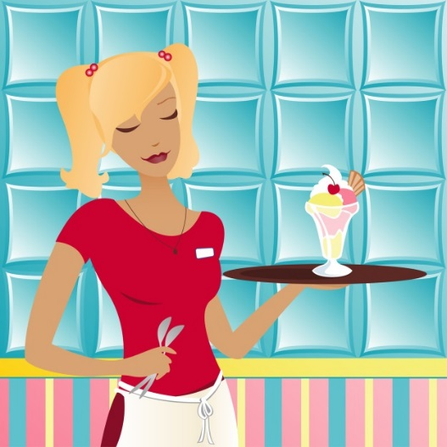In today's health-conscious fat-free society, customers stay away from desserts...NOT TRUE. We will offer some low-fat desserts, but you, the server, can always suggest splitting a dessert and bringing out additional forks or spoons. This is effective salesmanship that will increase your check, and also enhance your guests' experience.

# Wine Service

When ordering a bottle of wine, ring it up as usual on the register. The bartender will give you a chit that you will take to the manager, who, in turn, will issue the bottle.

Present the bottle to the host.

1. 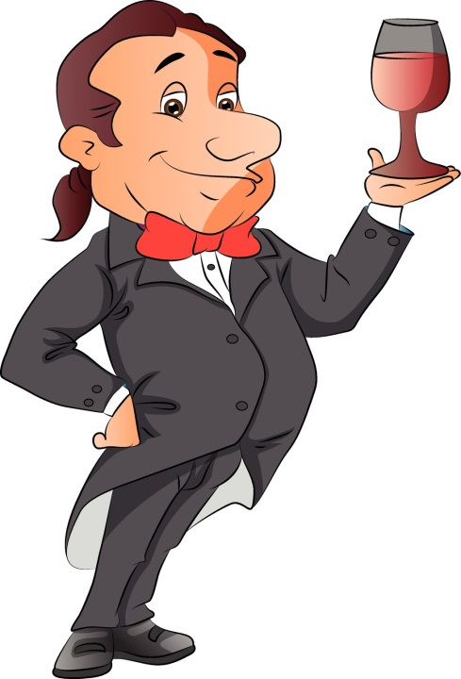Host accepts
2. Host rejects (wrong wine, wrong vintage, changed mind)

Place glassware around the table at the position 4 o'clock from the water glass. Using your wine opener, cut the capsule and put it in your pocket. Remove the cork and present to the host.

Pour about one ounce for the host to sample.

1. Host accepts
2. Host rejects (based on color, smell, clarity, taste)

If this happens, GET A MANAGER immediately.

Pour wine around the table.

1. About 4 1/2 ounces per glass.
2. Women first, then men, then the host/hostess of the party.
3. Place remainder of bottle in an iced wine cooler.

## VARIATIONS

Red Wine

Bring it and open as soon as possible after the order, so it can breathe.

Do not cool, unless requested.

Second Bottle - Same Wine

Give the host or hostess the option of re-sampling.

Give the host or hostess the option of fresh glassware for everyone.

Second Bottle - Different Wine

Automatically present fresh glassware.

Two Wines simultaneously

Host or hostess gets two glasses.

Host or hostess samples both wines before pouring to the rest of the party.

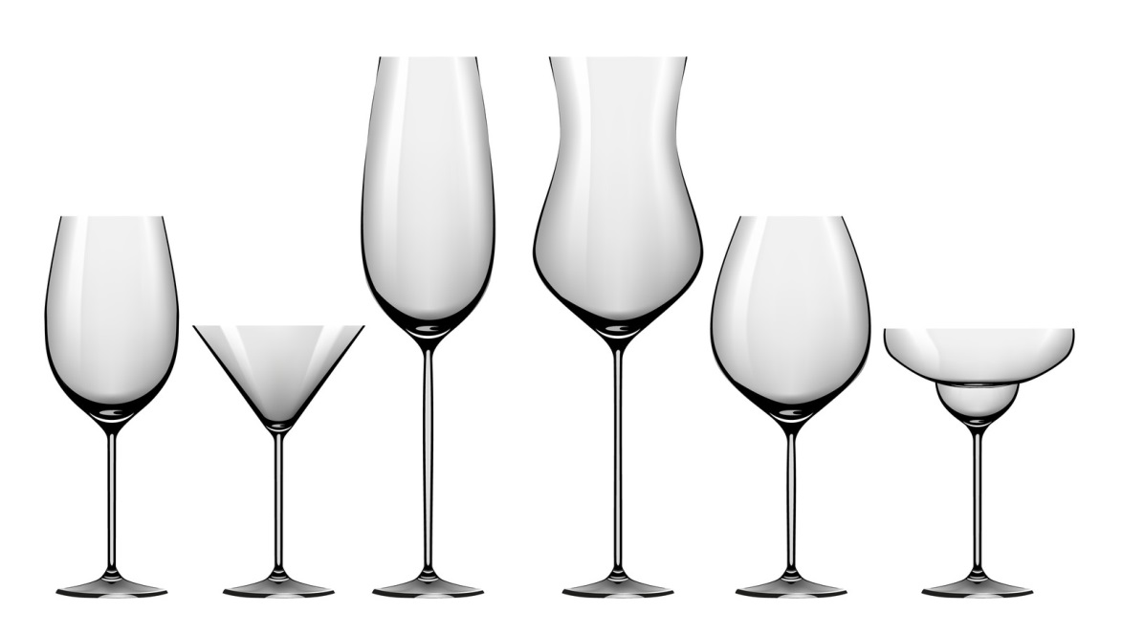All members of party must be given a choice of either.

# Closing Out A Table

## Presenting the Check

1. Before presenting the check, look it over to make sure you have charged for everything correctly.

Sides

Desserts

Coffee

Wine

Appetizers

Soups

Salads

Entrees

1. **After you have determined that the check is correct:** give the check to the host of the table (if known) or place it in the center of the table and say, "Thank you.” Make sure to let the customer know that you are the cashier and will take care of the check whenever they are ready.
2. **After presenting the check:** take a few steps and glance back at the table. If they already have their cash or credit card ready, it may mean they are in a hurry to leave. If this is the case, try to close the transaction immediately or as soon as possible. Guests will notice and appreciate this.

**We use a server banking system; you are your own cashier.** You are responsible for all your money, including cash, credit card vouchers, comps and discounts until the end of your shift. You must start your shift with your own thirty-five dollars that is used to make your opening change bank. **A sales station can only be opened or closed by a manager. NO EXCEPTIONS.**

**If the customer is paying cash, do not make change right at the table!!** Take the check and cash to the back-of-house and make change. Return the check and change on either a tip tray, or a book, along with the receipt. If the customer is paying with a credit card, follow the house procedure. Once the guest has signed the voucher, pick up both the check and voucher, and again, thank the customer. **DO NOT examine the tip as you leave the dining room!!**

REMEMBER, the process of closing out the check is the time when the guest is deciding on the tip amount. A bad impression here can undo all previous good impressions and effect your gratuity.

## The Farewell

When your guests are departing, we have four distinct objectives:

1. To make sure their experience in our restaurant was pleasurable.
2. Thank them, by name, for their patronage.
3. To invite them back for another visit soon.
4. To make sure their last impression is a positive one.

# Methods of Payment

Approved methods of payment are cash, VISA, Master Card, and American Express.

## Cash Handling procedure

Here are the procedures to follow when receiving a payment in cash:

1. 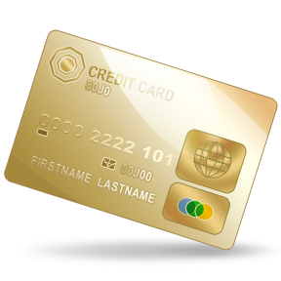Never make change at the table - go to the nearest server station and always count it twice.
2. Give the guest some one’s and five-dollar bills that they can use to tip you.
3. Return the change to the guest's table on a tip tray or book.
4. Always keep your cash and receipts in a server wallet or your apron.
5. Never leave your money or server wallet unattended.
6. If you are concerned about carrying too much cash during a shift, make a drop with a manager in exchange for an IOU.
7. Accurately cash out at the end of your shift with all monies due properly deposited in the cash drawer accurately balanced.

## Card Handling Procedure

**The Authorized Process**

Use **extreme** care when applying a charge to a guest’s card. Accurately ring up all the guest transactions with the correct menu pricing and on the correct credit card.

**Read your screen! Check, Check, Double Check!**

Ask yourself, “Am I positive that I am charging he correct amount to the correct card?” Verify accuracy by double-checking the last 4 digits of the credit card number.

You may easily void credit card mistakes or an entire transaction if the tip has not yet been entered. This is your last chance to check and correct any mistakes!

The check is neither closed nor is the guest’s card charged until you have entered your tip.

Do not enter a (0) in the tip field unless you have received a zero tip and intend to close out a charge. Entering a 0 tip before printing a charge closes out that check; you will not be issued a charge voucher for the guest to sign.

**Credit card handlers MUST:**

* Never leave a guest’s card unattended.
* Obtain proper authorization for a credit card transaction. If you are unable to obtain authorization through the card swipe, you must either key in the card number.
* Accurately close out tip amounts to guest cards.
* Never alter the tip amount written by the guest.
* If you suspect a tip amount has been altered, you must show it to a manager immediately.
* Never use a guest’s card or card number for any purpose other than charging the guest’s purchase.
* Obtain the guest’s signature on the receipt.

**If a guest makes an addition error when adding the tip to the check total,** a manager must be advised of the discrepancy. The close out check should be initialed by the manager acknowledging they were of the addition error.

# Check-Out Procedures

At the end of your shift, you are required to do an accountability or checkout, which you turn into the manager.

## Before you Start the Paperwork Process, You MUST:

* Complete your sidework, including salt, pepper and sugar caddies.
* Check out with the shift leader and have them sign the purple chit.
* Verify that all of your checks have been closed out to transferred. Do a ***Cashout Report*** including your closed checks. **Do not clear your totals until you have balanced the physical paperwork.**

## Accountability process

1. Sort all forms of payment into separate stacks.
2. All paper forms of payment require an adding machine tape total for each individual stack. The tape should be stapled to the top of each stack and include your name, day, date, POS number, shift and station (if applicable).
3. Staple all your *credit card* charges and *gift card* receipts together, keeping the final receipt slip and the copy with guest’s signature together. (If you have any zero balance gift cards, clip the corner and turn them in as well.)
4. If you have credit card and gift card charges, run two tape totals to verify your credit card *and* gift card charges against **Credit Card Total** stated on the **Cashout Report**
   * Tape of the base amount plus tips [Ex. (24 + 4) + (30 + 6) + (100 + 15) = 179]
   * Tape if the final amounts added together [Ex. 28 + 36 + 115 = 179]

**If the totals for the two stacks do not match:**

There is a mistake somewhere and you must find and correct it before you go on.

Start to look for the mistake by re-reading the tapes or check the addition on the charge slips. If there is a mistake in the guest’s addition, you must see a manager. Only a manager may adjust or correct the total on a charge.

If you have lost a charge voucher and cannot find it, you must see a manager.

**Accountability process**

* If you have one or more adjustments, run a tape total. Each quality issue adjustment must have a manager signature on it. Quality issue adjustments are a payment method and when missing are considered to be shortages.

**Gift Certificates**

* If you redeemed one or more gift certificates: run a tape total to verify your gift certificates redeemed.
* **Note:** When gift certificates are redeemed in conjunction with a credit card payment, attach a second copy of the credit card voucher to the gift certificate. Do not mix gift certificate in with credit card vouchers.

**Cash**

* Count and verify your cash against the ***Cash to Remit*** on the **Cashout Report.**

**Zeroing Totals**

After you have balanced your *physical paperwork* totals against your first printout of your Cashout Report, print a second report. This time you will touch ***YES*** when prompted to clear your totals for the shift. No need to include your closed checks on your zeroed Cashout. (Staff you have a negatice cash accountability need to rin a 2nd *not zeroed* copy of the Cashout Report before cleaing totals and receiving a 3rd copy of the report. You will turn-in one copy to the cashiet to receive the balance of your tips owed.

**Time out**

Be Certain to “Time Out” in the POS system after every shift.

1. Select Timeclock
2. Swipe card
3. Select punch out
4. Declare tips and tear off receipt

**Tip Declarations**

1. When you clock out, you will be prompted to declare your total top amount. (This amount is the total tip amount, which must include charged and cash tips retained after tip out.)
2. After you enter in the total tip amount, the system will automatically deduct any charged tips and calculate the cash tips amount accordingly. You will have the opportunity to confirm your total tip amount when you touch the “Punch Out” button.
3. Once you have confirmed your tip amount, your timecard will print out and will include a breakdown of your declared tips. Save this report for your records.

# Alcohol Awareness

The Maple Leaf Diner is committed to serving alcohol responsibly. Managers and staff must take all reasonable steps to prevent underage drinking, alcohol over consumption and to prevent our guests from driving while under the influence of alcohol. The reputation of our restaurant is at stake.

**The law**

The legal drinking age is 21 in all states.

Third party liability laws read that the server of alcohol and the restaurant establishment are held liable when a guest consumes alcohol, leaves the premises and then cases injury or death to himself or someone else. The law requires that a server make *reasonable effort* to prevent intoxication in guests, prevent alcohol sales to minors and intervene if a guest does become intoxicated.

**intoxication behavioral cues**

* **Inhibitions** – Becomes talkative, relaxed, over-friendly, loses self-control, and sometimes displays mood swings.
* **Judgment** – Behaves inappropriately, such as ordering doubles at last call, uses foul language, tells off-color jokes or annoys others.
* **Reactions** – Classy, unfocused eyes, talks or moves very slowly, forgets things, slurred speech.
* **Coordination** – Stumbles or sways, drops belongings, has trouble picking up a drink.

**Identification request or “carding”**

As a bartender and/or server, you must make certain that the person you are serving to is of legal age.

**Anyone that appears under 30 years of age is required to have a valid ID**

Notify a manager immediately if guests have any problems with this request.

**Acceptable forms of id**

* Valid driver’s license
* Valid state-issued ID card
* U.S. active-duty military ID
* Valid Passport

**Steps to checking id**

1. Ask the guest to remove the ID from his/her wallet.
2. Determine whether the ID is valid by:
   1. Checking the birthdate
   2. Checking the expiration date.

**If you suspect a problem or discrepancy with the identification offered, get a manager immediately.**

# Safety & Sanitation

**General Policy**

The responsibility of management and staff to protect the public from food borne illness is fundamental.

A **food borne illness** is simply a disease that is carried, or transmitted, to human beings by food.

Throughout your training, you will receive information concerning proper temperatures of food storage and serving, as well as, cleanliness standards, proper use of chemical cleaning, and disinfectant products. It is our objective to operate the restaurant at the highest level of cleanliness and sanitation for the benefit of our customers and employees. **Refer to our safety and sanitation policies in the Employee Handbook.**

**Beverage Service**

* **Always** use a designated ice scoop (Never use a glass to scoop ice).
* **Always** store ice scoops in a desingted container.
* **Always** use the deesinated tongs to retrieve lemon wedges.
* When refilling beverages, **never** touch the guests glass or straw to the pitcher.
* When refilling beverages at the soda station, ensure that the straw never touches the soda and nozzle.
* **Always** store ice bickets inverted on a hook. They should **never** be sotred directly on the foor.

# Conclusion

There is a lot of information contained in this manual! Believe it or not, however, there is even more information that is not.

We have given you the basics, as we view them, and how we would like them to be conducted.

We want you to use the service tips in the manual, along with your common sense, and above all, YOUR individuality, to help create an atmosphere that will encourage good times for our customers, and yourself. If this happens, you will be ensuring the success of not only the restaurant, but also yourself.

GOOD LUCK!!!